

TASCO Motor Insurance Growth Platform · TGP-MAN-02
Customer App Guide
Date – 08 October 2026
Version – 1.0
Prepared by – iorta TechNXT
TABLE OF CONTENTS
1. Document Control 3
2. Acronyms 3
3. Introduction 4
3.1. Purpose 4
3.2. Scope 4
3.3. Audience 4
3.4. Related documents 4
4. Where the app runs 4
5. Safety messages for customers 5
6. Getting around 5
7. Home 6
7.1. Confirm the expiry date 7
8. Buy or renew 8
8.1. Quick renewal 9
8.2. Full flow 10
8.2.1. Step 1: choose cover 10
8.2.2. Step 2: review 11
8.2.3. Step 3: pay 13
8.3. Example premiums 14
9. My insurance and the e-certificate 15
10. Report an accident 16
10.1. In an emergency 16
10.2. The claims tab 16
10.3. Submit a report 16
11. Account 18
12. Contact TASCO 20
13. Messages the customer may see 23
14. Frequently asked questions 23
14.1. Is the call from the automated assistant genuine? 23
14.2. Why do I see “Gia hạn nhanh” and my friend does not? 24
14.3. Is it cheaper to buy in the app? 24
14.4. A telesales advisor sent me a quote. How do I pay? 24
14.5. I already bought insurance elsewhere. How do I stop the reminders? 24
14.6. The payment failed. Was I charged? 24
14.7. I sold the car or the assistant called the wrong person. 24
15. Appendix 24
15.1. Screen and label summary 24
16. Sign-Off 26

Document Control

Date | Version | Author & Business Unit Info | Reviewed By & Business Unit Info | Approved By & Business Unit Info | Change History
08/10/2026 | 1.0 | iorta TechNXT  Business Analysis and User Experience | TASCO Insurance  Product Owner | TASCO Insurance  Programme Sponsor | Initial issue for submission

Acronyms

Acronym / Symbol | Definition / Meaning
ATM | Automated teller machine (domestic bank card)
OTP | One-time password
PNG | Portable Network Graphics (image file)
QR | Quick response (code)
SMS | Short message service
TNDS | Compulsory motor third-party liability insurance (Bảo hiểm TNDS bắt buộc)
VAT | Value-added tax

Introduction

Purpose
This guide explains what customers see and do in the TASCO customer app: checking their cover, renewing or buying motor insurance, paying, keeping the e-certificate, reporting an accident, managing consent and contacting TASCO. It is written for TASCO and VETC customer service, telesales and training staff, who answer customers’ questions, and for the teams that approve the customer wording.

Scope
The app is in Vietnamese only. Screen labels are quoted exactly as they appear in the app, in bold, with an English explanation where it helps. Amounts in the examples come from the sandbox: TNDS premiums follow the regulated tariff, and the seat accident and physical damage rates are illustrative until TASCO’s filed rates are loaded.
The staff side of the same journeys (quotes sent by telesales, claims handling, data corrections) is described in TGP-MAN-01 Staff Console User Manual.

Audience
TASCO and VETC customer service and telesales staff, trainers, the TASCO product owner and compliance.

Related documents
ID | Title
TGP-BUS-06 | Personas and Customer Journeys
TGP-UX-03 | Information Architecture and Navigation
TGP-MAN-01 | Staff Console User Manual
TGP-MAN-03 | Partner API Integration Guide

Where the app runs
The same app runs in four places. The content, the steps and the TASCO Insurance brand are identical in all of them; only the payment method and a few messages follow the host. The VETC app is the host for the pilot; the other three come with the scale phase.
Host | How the customer opens it | Payment method | Release
VETC app | The Insurance section, or a renewal link in a VETC notification, Zalo message or SMS | Ví VETC (VETC wallet) | Pilot
Zalo Mini App | The VETC mini app inside Zalo | Ví VETC | Scale phase (S4)
TASCO app | The insurance section of TASCO’s own app | Thanh toán qua cổng TASCO (TASCO payment gateway: domestic ATM card, international card or bank QR) | Scale phase (S3)
TASCO website | A link from baohiemtasco.vn | Thanh toán qua cổng TASCO | Scale phase (S3)
The TASCO payment gateway is a sandbox adapter until TASCO’s gateway integration is specified.
The host opens the app with a signed link that identifies the customer’s vehicle; the customer does not create a password. A renewal link is valid for 30 days. If the link has expired, the app says “Liên kết đã hết hạn hoặc không hợp lệ” (the link has expired or is not valid) and asks the customer to open it again from the host app.
Messages in the app name the host, for example “Mở lại từ ứng dụng VETC” or “Mở lại từ website Bảo hiểm TASCO”.

Safety messages for customers
Two messages appear at the foot of the main screens and should be repeated by every staff member who talks to customers.
- Phí bảo hiểm TNDS bắt buộc theo quy định của Bộ Tài chính. The TNDS premium is set by the Ministry of Finance and is the same at every insurer. TASCO offers no discount on it; the value is in the service.
- VETC và TASCO không bao giờ yêu cầu mã OTP qua điện thoại. Neither VETC nor TASCO ever asks for an OTP code, wallet PIN or card details by phone or message. Payment is made only inside the app. In the TASCO app and on the TASCO website the message reads TASCO không bao giờ yêu cầu mã OTP qua điện thoại.

Getting around
The bottom tab bar has four tabs.
Tab | What it is for
Trang chủ (Home) | Cover status, a quote waiting for payment, quick actions and the benefits that come with the cover
Bảo hiểm của tôi (My insurance) | Policies and e-certificates with their QR codes
Bồi thường (Claims) | Report an accident and follow claims
Tài khoản (Account) | Consent choices, personal data, support contacts and sign-out
Task flows (buying, reporting an accident, confirming the expiry date) open full screen with a back arrow at the top left and the main button fixed at the bottom.
The round support button (headset icon) at the bottom right of the tab pages opens the support sheet. It is hidden during checkout so that it cannot interrupt a payment.

Home
The home screen greets the customer by first name and shows a card for the vehicle: the plate, the vehicle type, the year of first registration, the province, and a ring counting the days of cover left.
The status chip on the card and the main button depend on the cover:
Chip | Meaning | Main button
Đang hiệu lực | In force | Xem giấy chứng nhận (view certificate)
Sắp hết hạn | Expires within 45 days | Gia hạn nhanh (quick renewal) with Tùy chỉnh gói bảo hiểm under it when the case allows it; otherwise Gia hạn ngay (renew now)
Đã hết hạn | Lapsed; the card warns that the vehicle has no compulsory TNDS cover | Gia hạn nhanh and Tùy chỉnh gói bảo hiểm when the case allows it; otherwise Mua bảo hiểm ngay (buy now)
Chưa rõ hạn bảo hiểm | The expiry date is unknown | Cập nhật ngày hết hạn (update the expiry date) and Mua bảo hiểm mới
Đã gia hạn | Renewed; the new policy starts on the date shown | None
When a quote from telesales is waiting, the quote card below is the call to action and the vehicle card shows no button. When quick renewal is not offered for a reason the customer can fix, a short hint sits under Gia hạn ngay, for example “Cần xác nhận thông tin xe” (the vehicle details need confirming) or “Số dư ví VETC chưa đủ để thanh toán” (the wallet balance is too low).
Under the vehicle card:
- Báo giá đang chờ bạn xác nhận (a quote waiting for your confirmation) appears when a TASCO telesales advisor has sent a quote. It shows each product, the period, Tổng thanh toán (total to pay) and when the quote expires. Xem và thanh toán opens it at the review step.
- Ngày hết hạn đã chính xác chưa? asks the customer to confirm the expiry date when TASCO’s record is uncertain. Xác nhận ngay opens the confirmation form.
- Quick actions: Cứu hộ (roadside assistance; calls the hotline 1900 1562), Báo tai nạn (report an accident), Giấy chứng nhận (certificates) and Mua bảo hiểm (buy insurance).
- Quyền lợi đi kèm: the service benefits that come with the cover, such as roadside assistance, the e-certificate with QR code and inspection reminders. Swipe sideways to see more.
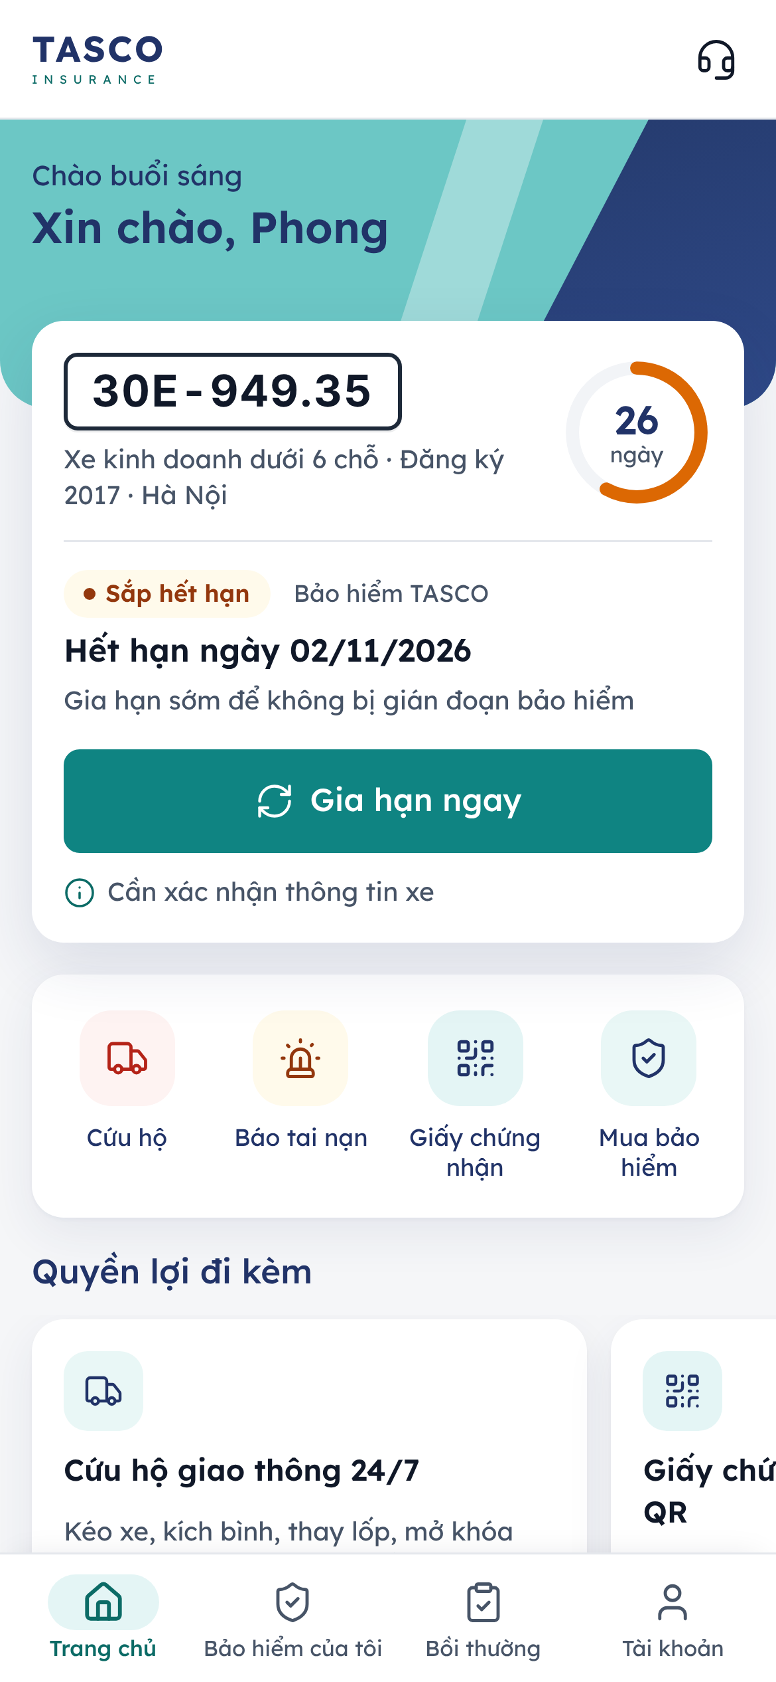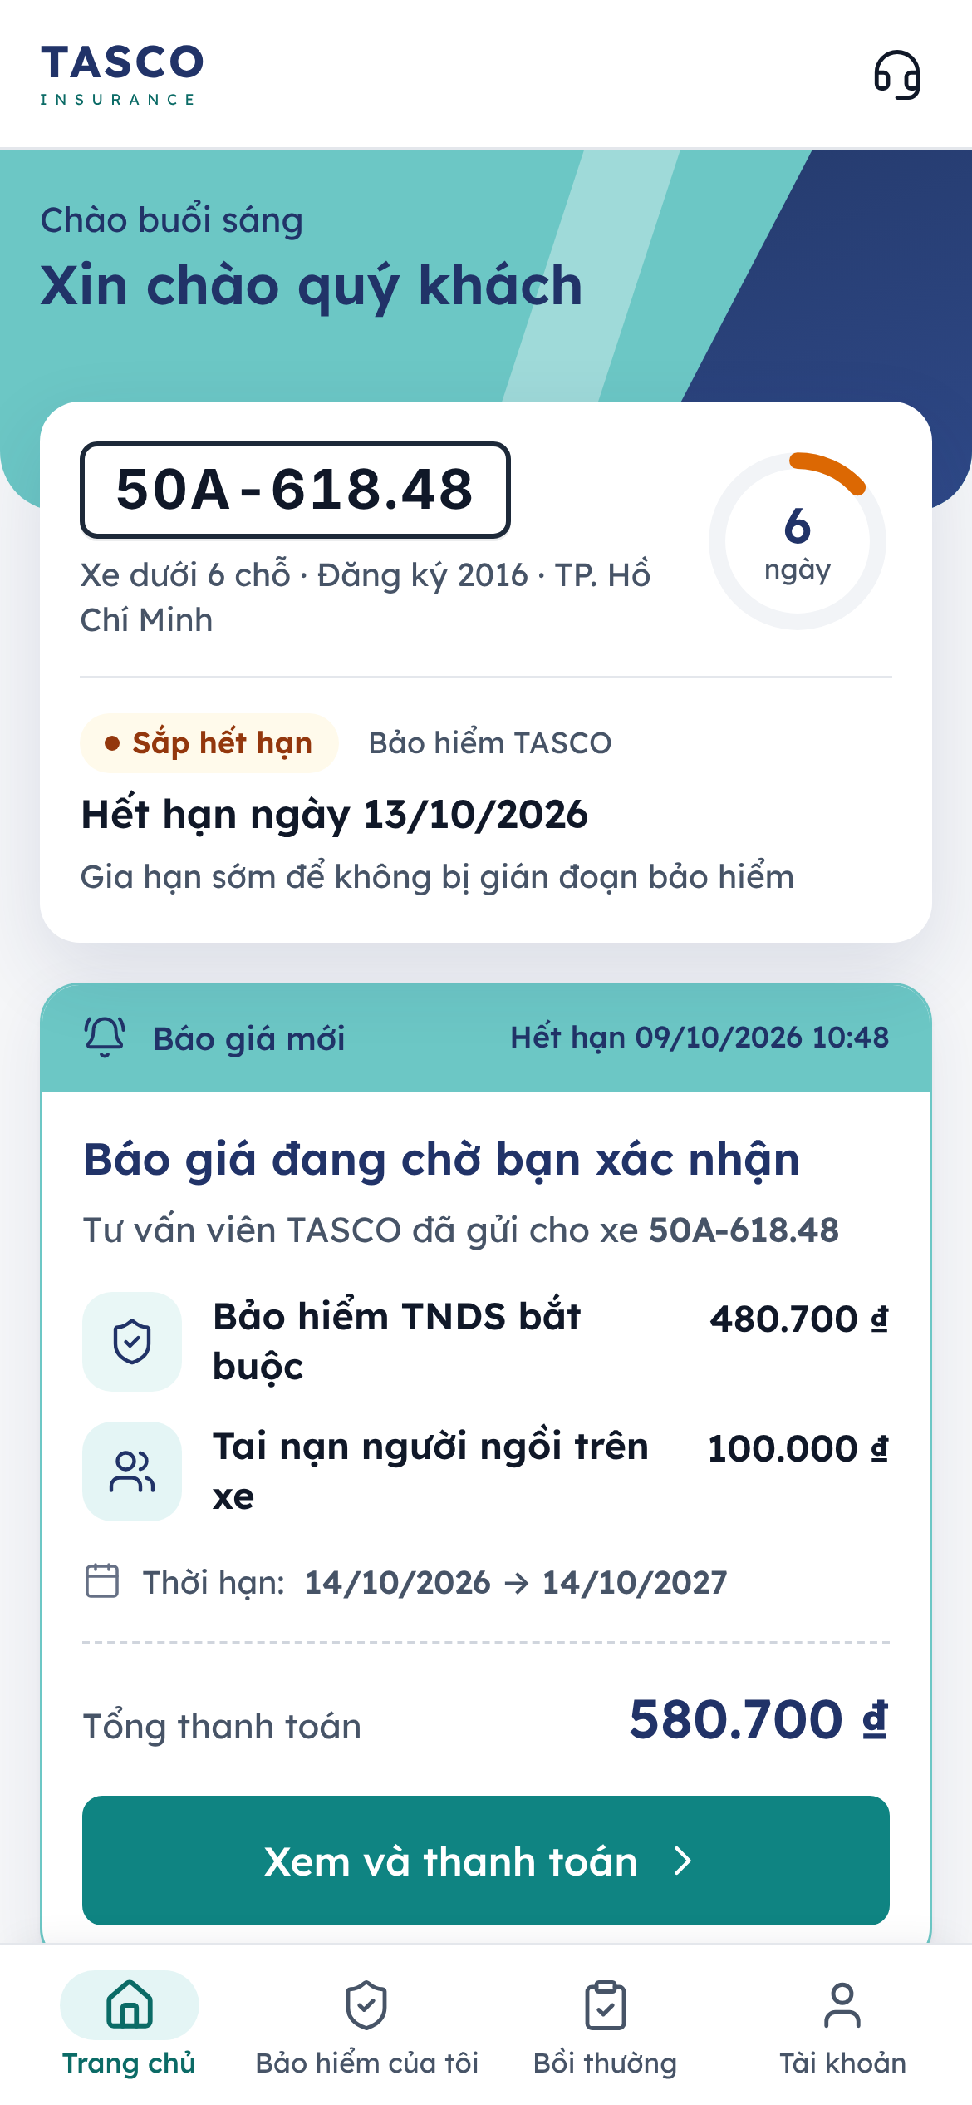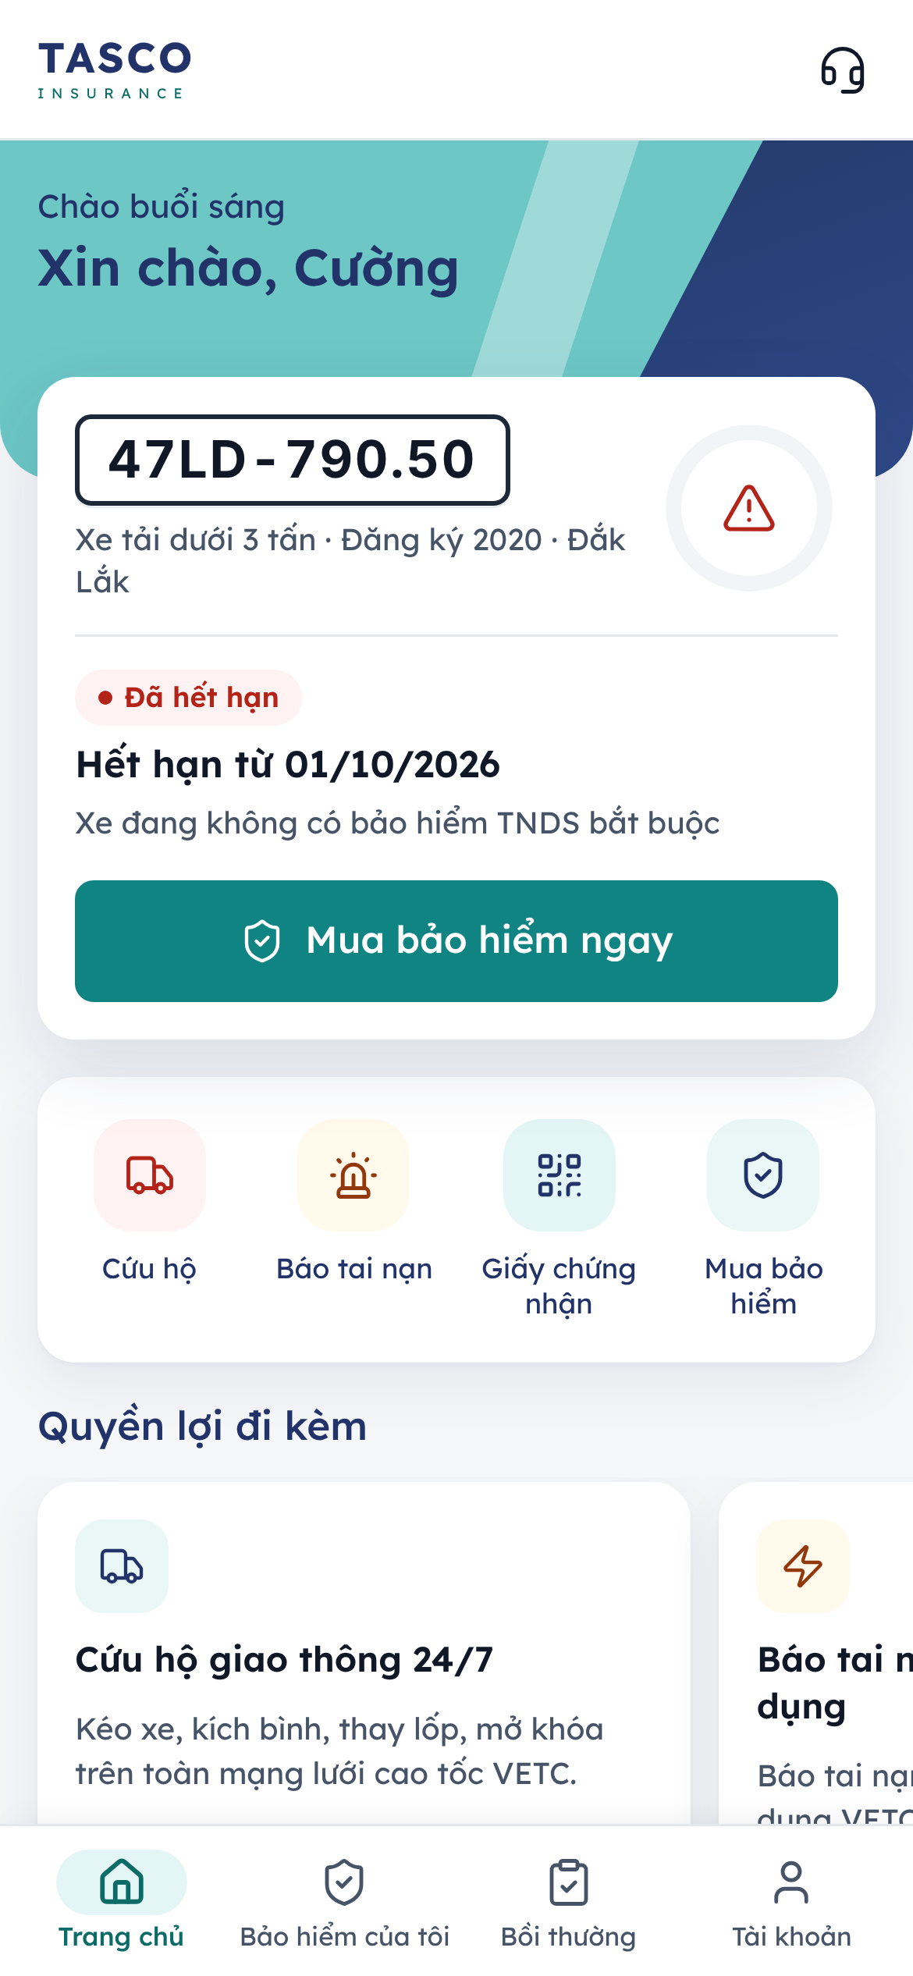
Figure 1 – Home: renewal due, a quote sent by telesales, and a vehicle without cover

Confirm the expiry date
TASCO often knows a vehicle’s expiry date only by estimate. When the customer confirms it, reminders arrive at the right time.
- Tap Xác nhận ngay or Cập nhật ngày hết hạn on the home screen.
- Under Ngày hết hạn, type the date shown on the current TNDS certificate as day/month/year, for example 07/10/2026.
- Under Công ty bảo hiểm hiện tại, choose the current insurer: TASCO, PVI, PTI, Bảo Việt, PJICO, BIC, MIC or Khác (other).
- Tap Lưu thông tin.
The app thanks the customer: “Cảm ơn bạn! Chúng tôi sẽ nhắc gia hạn đúng hạn.” The information is used only for reminders.
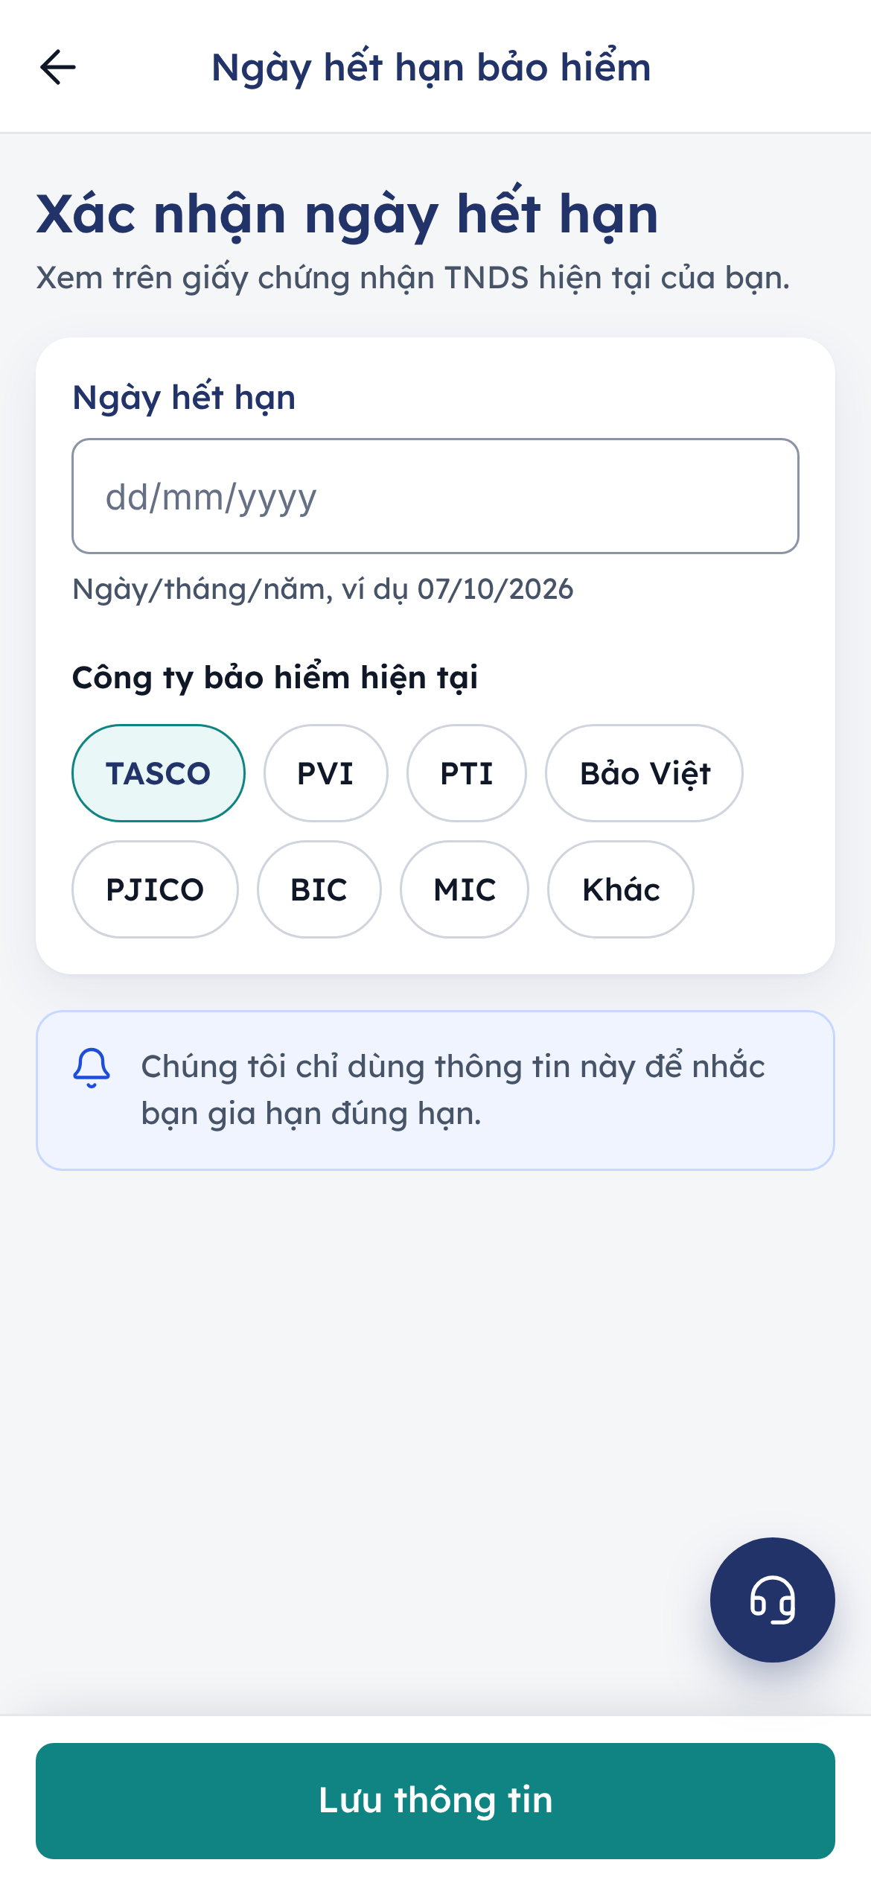
Figure 2 – Confirming the expiry date

Buy or renew
There are two ways to renew. The platform decides, case by case, which one the home screen offers.
Path | Taps | When the customer sees it
Quick renewal (Gia hạn nhanh) | 3: Gia hạn nhanh, the declaration tick, Xác nhận thanh toán | The renewal of a TNDS policy whose details TASCO already holds, when every condition below is met
Full flow | 6: Gia hạn ngay, Xem phí bảo hiểm, Tiếp tục, the declaration tick, Thanh toán, Xác nhận thanh toán | Every other case, and always available through Tùy chỉnh gói bảo hiểm (customise the cover)
Quick renewal is offered only when all of these hold:
- the customer is in a renewal journey or is renewing a TASCO TNDS policy;
- the vehicle has not already been renewed;
- the vehicle’s use and number of seats have been confirmed by TASCO core, by a matching TASCO policy, or by the customer within the last 365 days;
- the cover is TNDS alone, with no physical damage cover (which needs an inspection);
- TASCO can give the official price at once (the price would not be indicative);
- in the VETC app and the Zalo Mini App, the VETC wallet balance covers the premium.
TASCO sets these conditions in the service levels rule set; quick renewal can be switched off there without a release.

Quick renewal
- On the home screen, tap Gia hạn nhanh. The Gia hạn nhanh screen opens with the card Gia hạn TNDS bắt buộc (“Giữ nguyên thông tin xe và gói bảo hiểm hiện tại”: same vehicle details and same cover as now). It shows Biển số, Xe (vehicle type, seats and use), Thời hạn (the new period, for the same term as the current policy), the TNDS line with “Giá theo quy định của Bộ Tài chính”, Tổng thanh toán and the Phương thức thanh toán for the host.
- Tick Tôi xác nhận thông tin xe chính xác và đồng ý với quy tắc bảo hiểm của TASCO. The declaration stays an explicit step for compliance; without it the app says “Vui lòng xác nhận trước khi thanh toán.”
- Tap Xác nhận thanh toán. The payment is processed once only, and the same success screen as the full flow shows the policy number and the e-certificate.
To change anything (term, seats, extra cover), the customer taps Tùy chỉnh gói bảo hiểm on the home card or on the quick renewal screen, which opens the full flow.
If the case changes between the home screen and the quick renewal screen, the app explains why and offers the full flow instead: “Gia hạn nhanh chưa áp dụng cho xe này” with the reason and Gia hạn ngay, or “Đây là giá tạm tính” when TASCO’s rating system is busy, with Tùy chỉnh gói bảo hiểm to confirm the official price in the full flow.
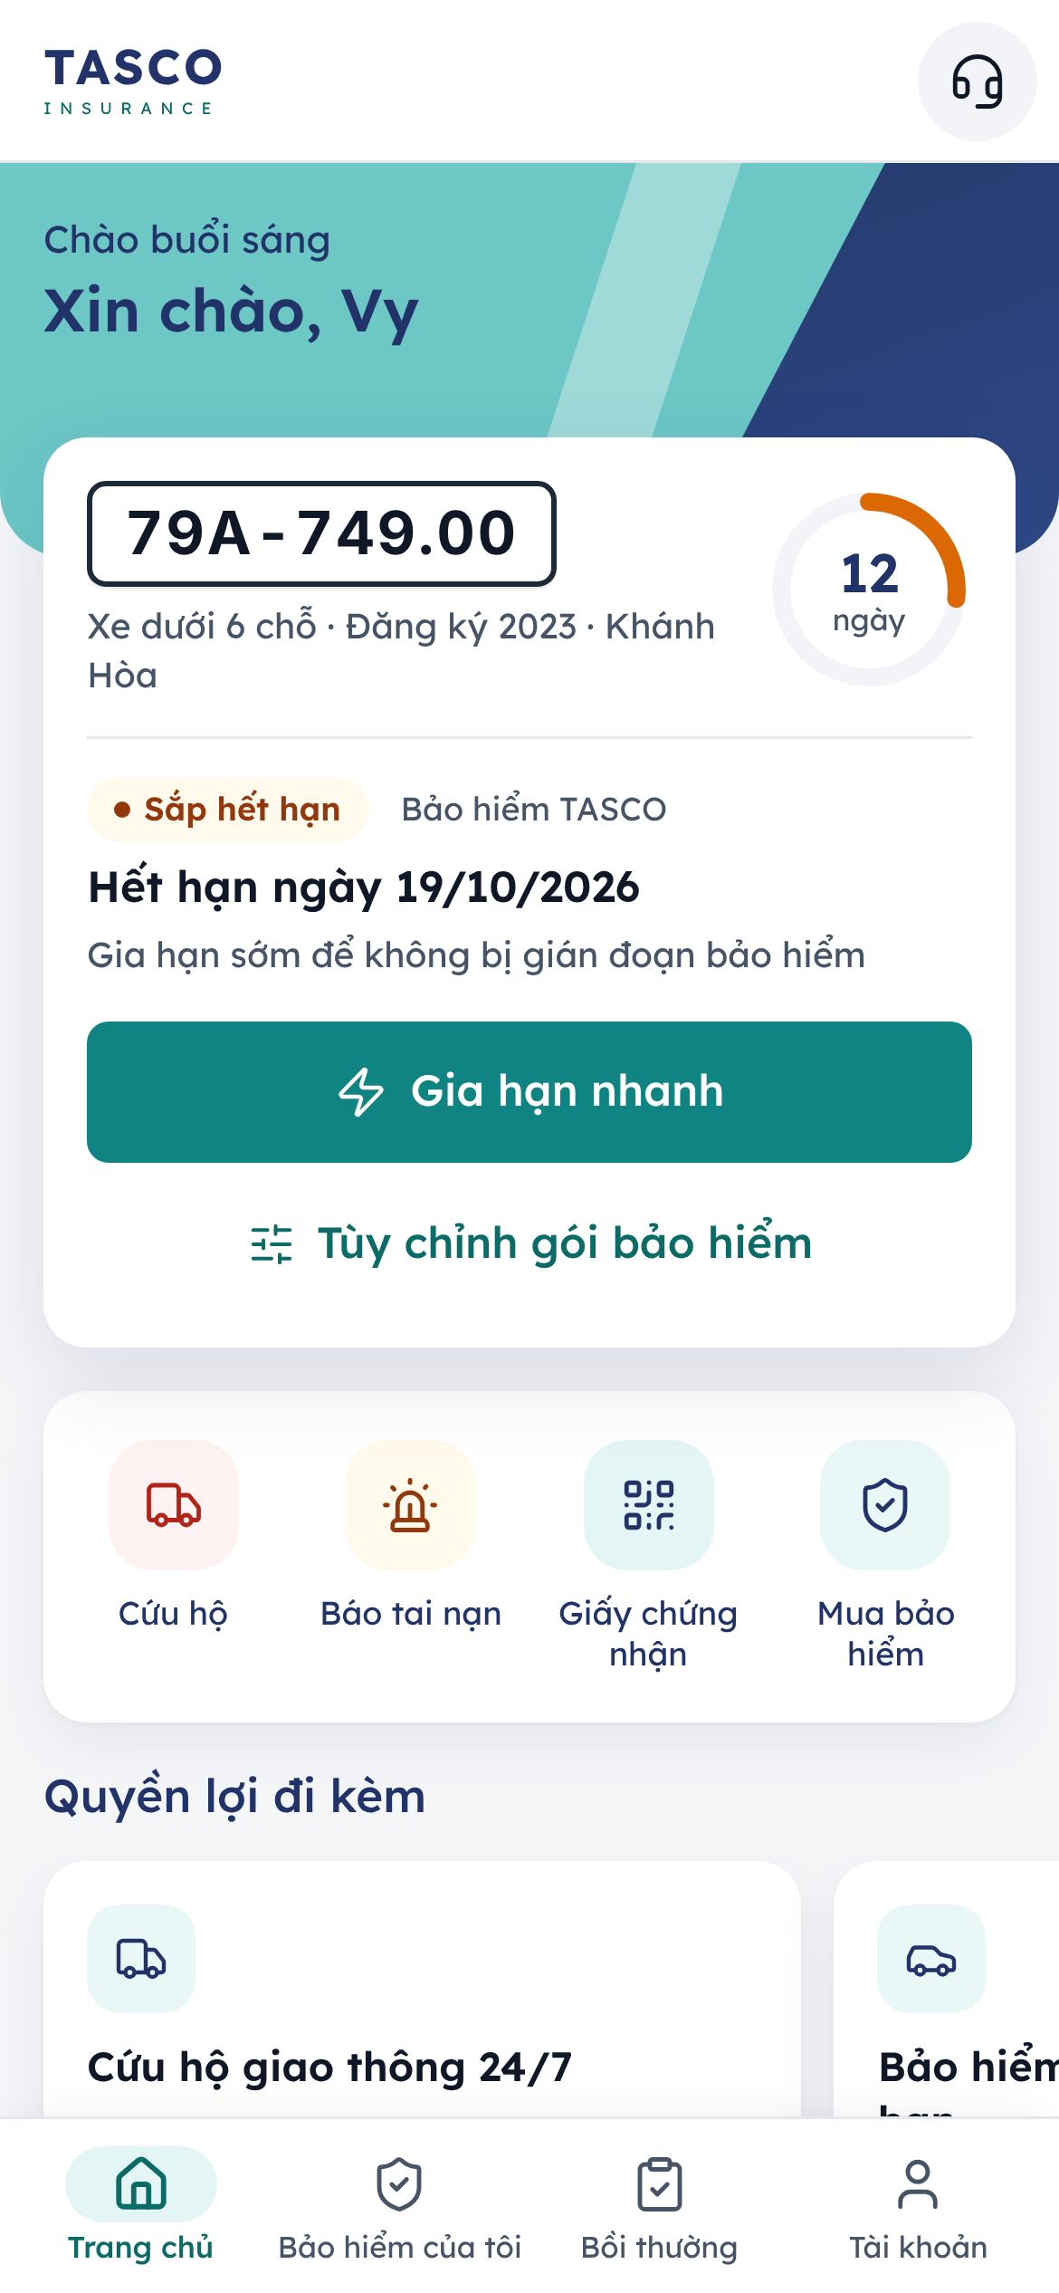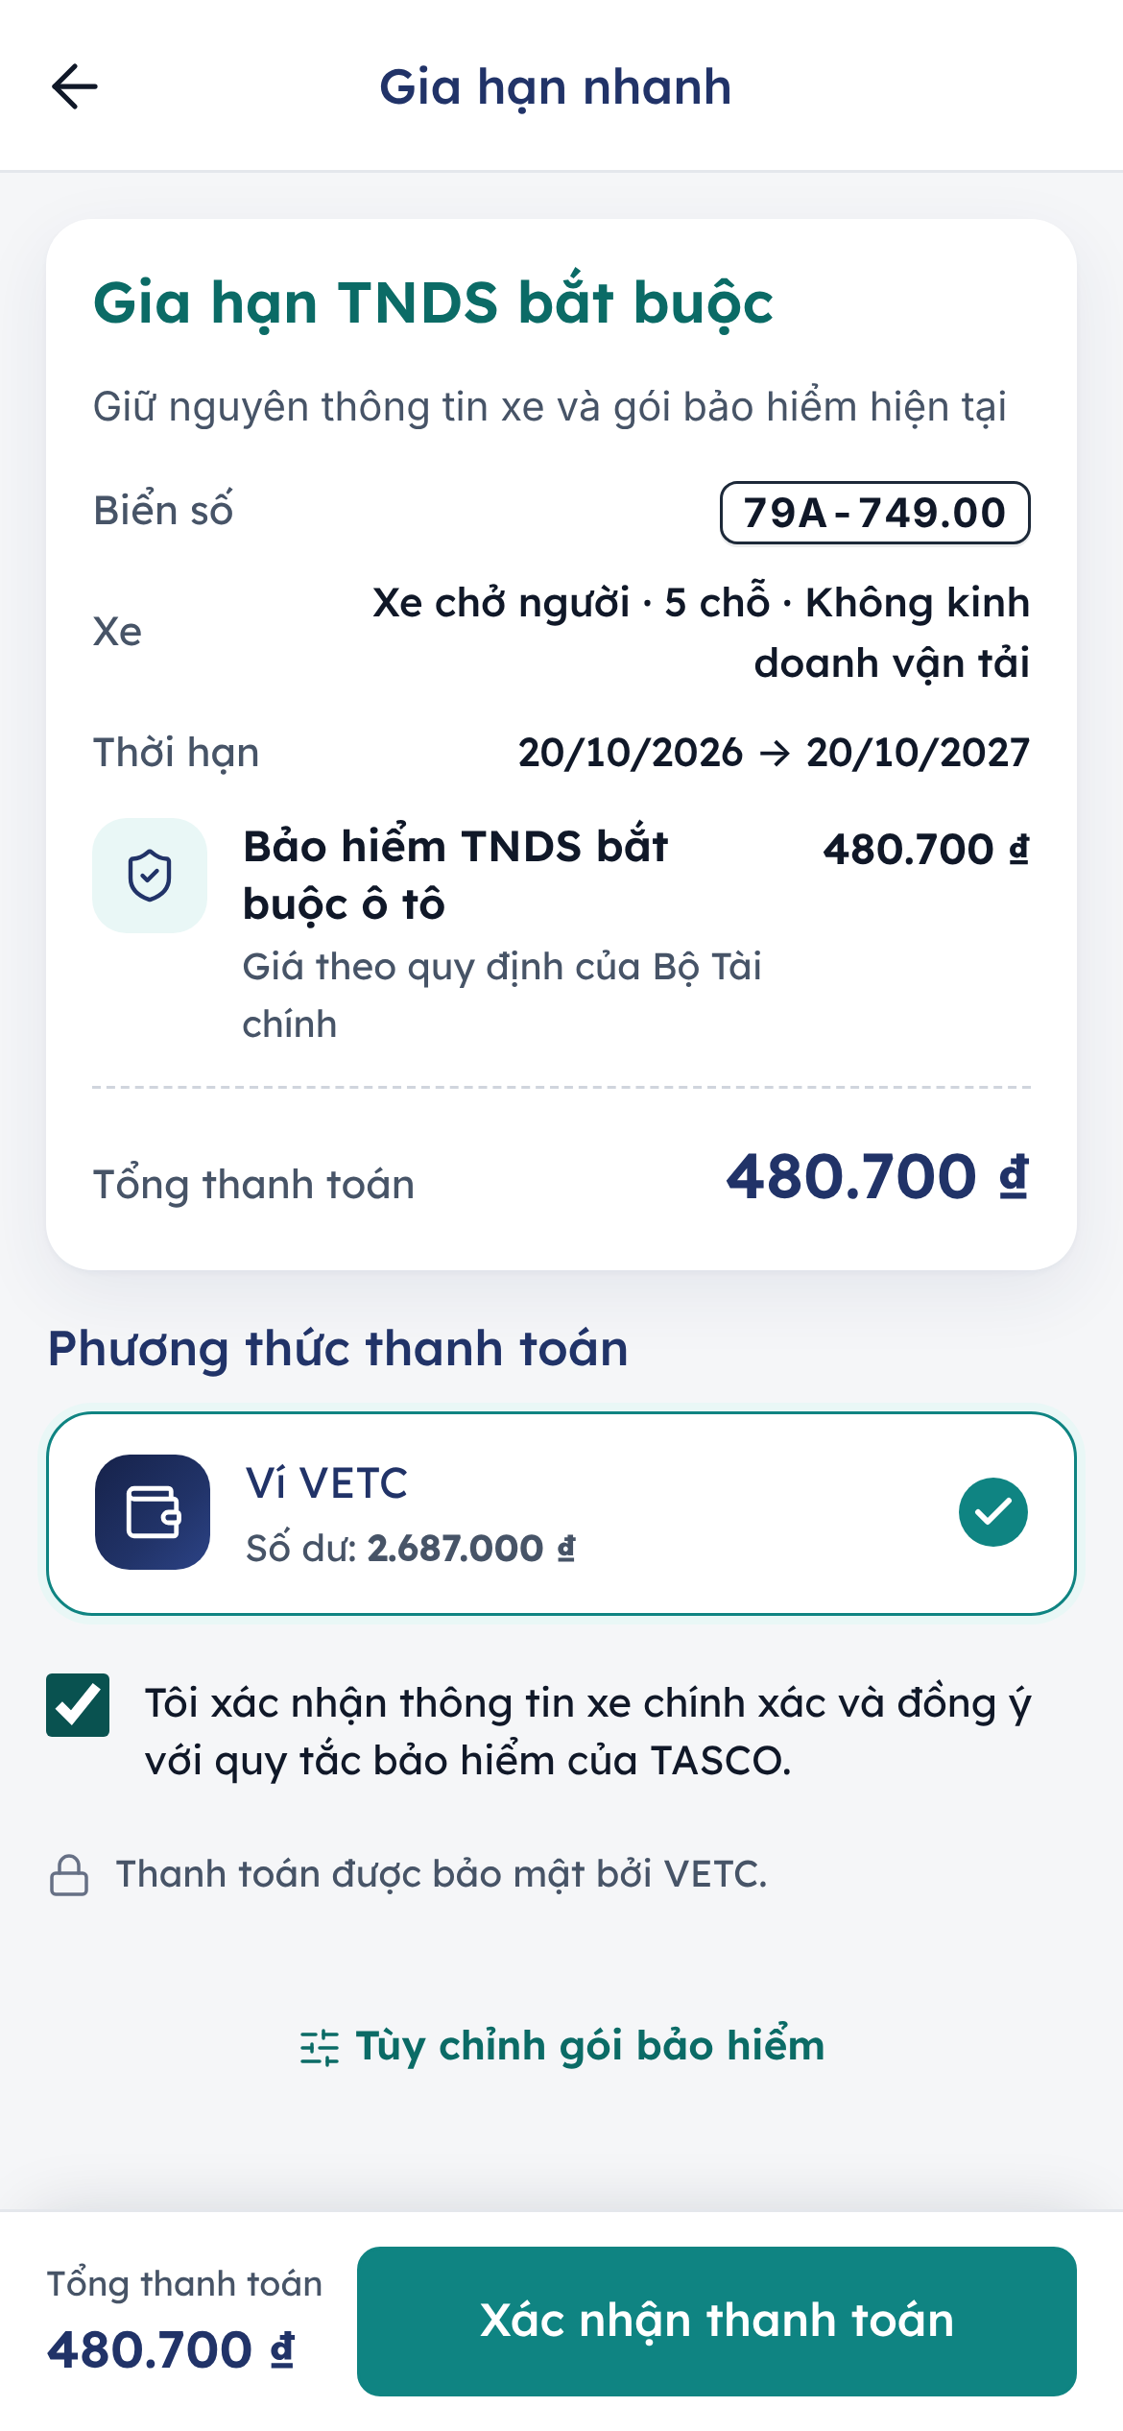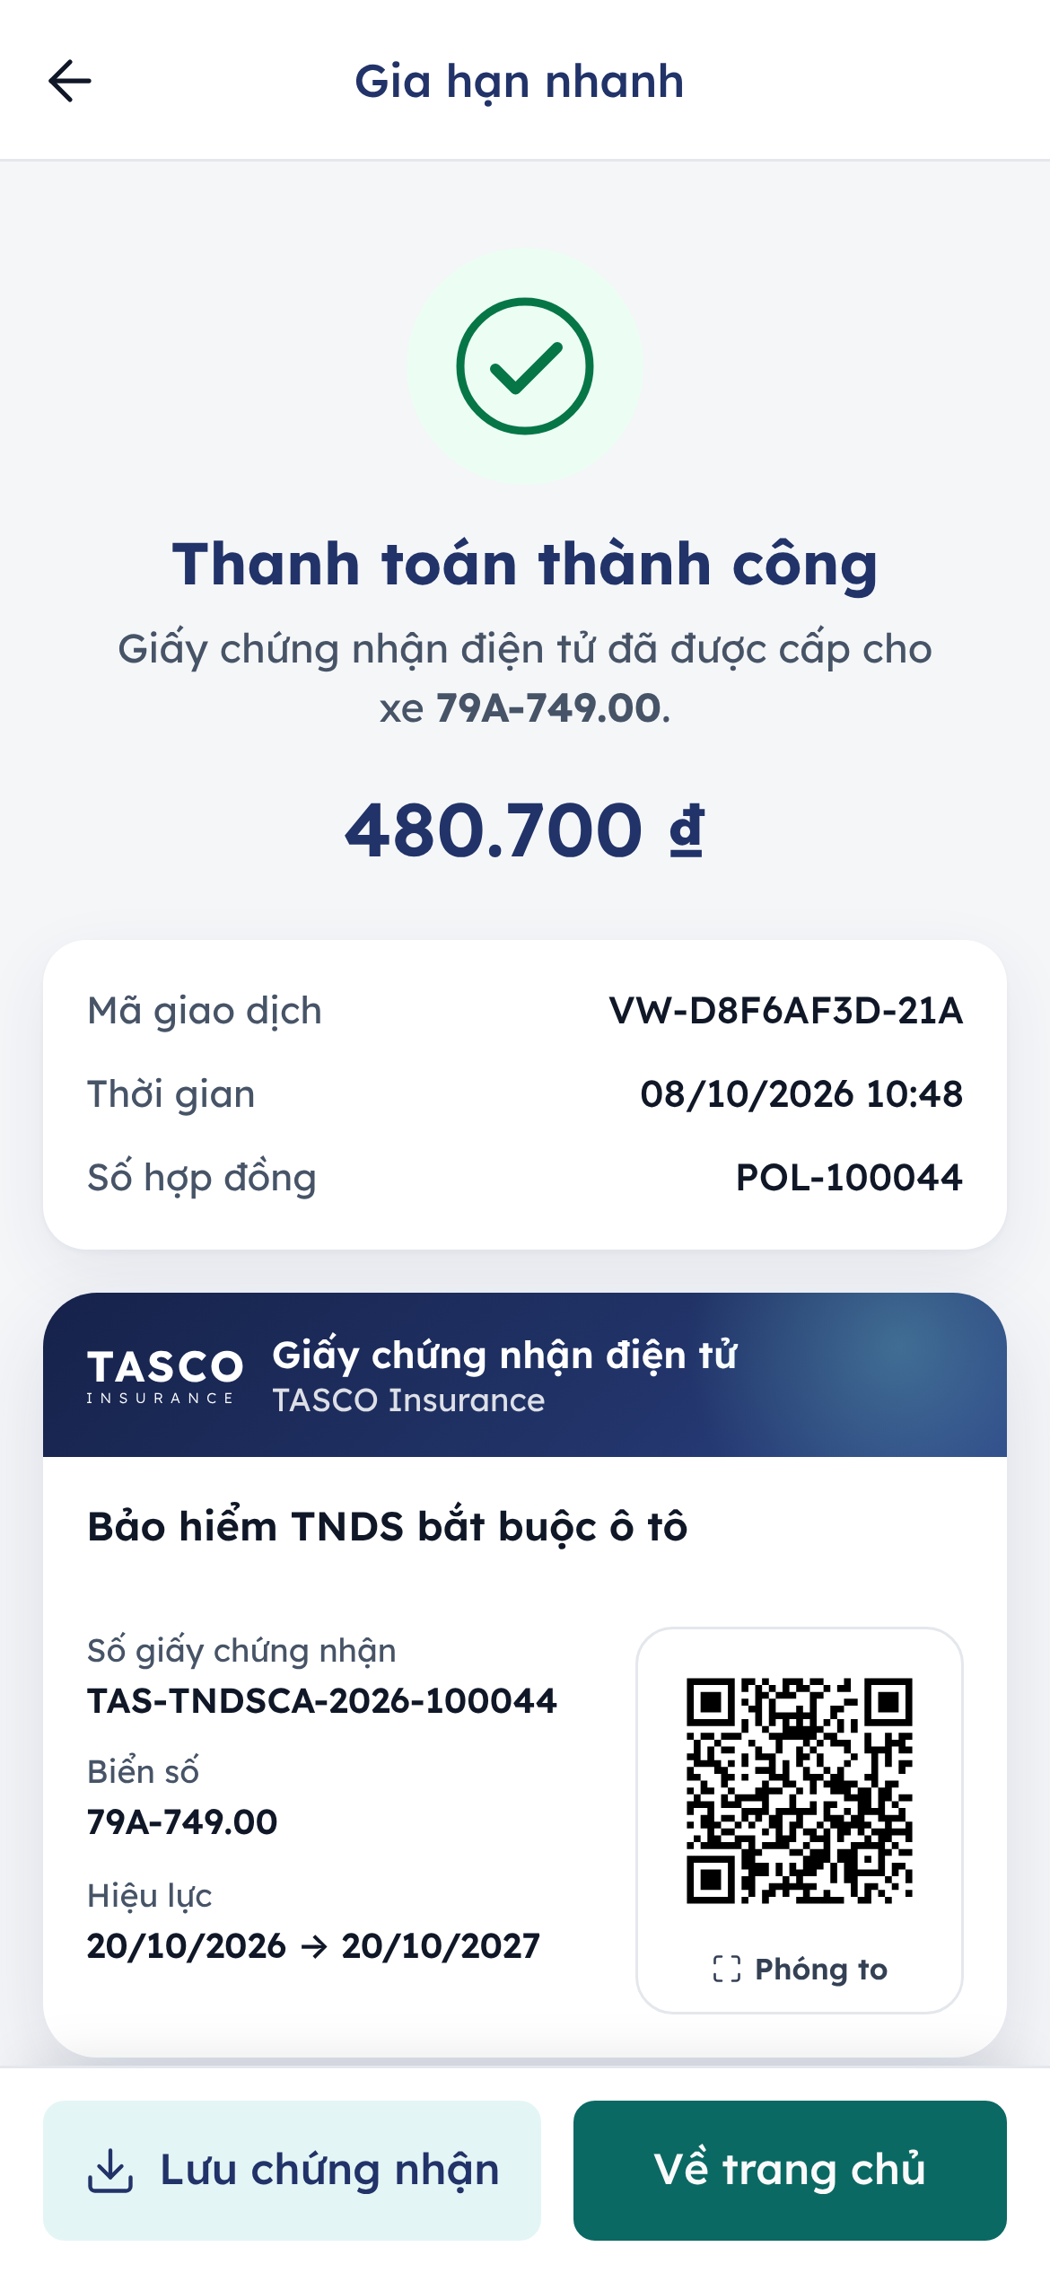
Figure 3 – Quick renewal: the home card with “Gia hạn nhanh”, the review and pay screen, and the success screen

Full flow
The full purchase flow is used for a new purchase, for a renewal that does not qualify for quick renewal, for a customer who wants to change the cover, and for a quote sent by telesales. It has three steps shown in a stepper at the top: Chọn gói (choose cover), Xác nhận (review) and Thanh toán (pay). From the home screen, a renewal takes six taps.

Step 1: choose cover
The form is titled Bảo hiểm TNDS bắt buộc xe ô tô and shows the plate and vehicle.
- Answer Xe có kinh doanh vận tải không? (is the vehicle used for commercial transport?): Không or Có.
- Check Loại xe (vehicle type, read-only, taken from the registration) and enter Số chỗ ngồi (number of seats, 1 to 60).
- Choose Thời hạn bảo hiểm (term): 1 năm, 2 năm or 3 năm. The line underneath shows the regulated annual premium, for example 480.700 ₫/năm for a car under six seats.
- Under Bảo vệ thêm (optional extra cover), switch on what the customer wants:
  - Tai nạn người ngồi trên xe: accident cover for the driver and passengers, 20 million đồng per person.
  - Vật chất xe: physical damage cover for the customer’s own car. Enter Giá trị xe hiện tại (current market value, at least 100.000.000 ₫). A note says Cần giám định xe: a TASCO assessor must inspect the vehicle before this cover can be issued.
- Tap Xem phí bảo hiểm (see the premium).
The compulsory premium depends on the vehicle’s use and number of seats, so changes to these answers are saved to the vehicle’s record and the price is recalculated.
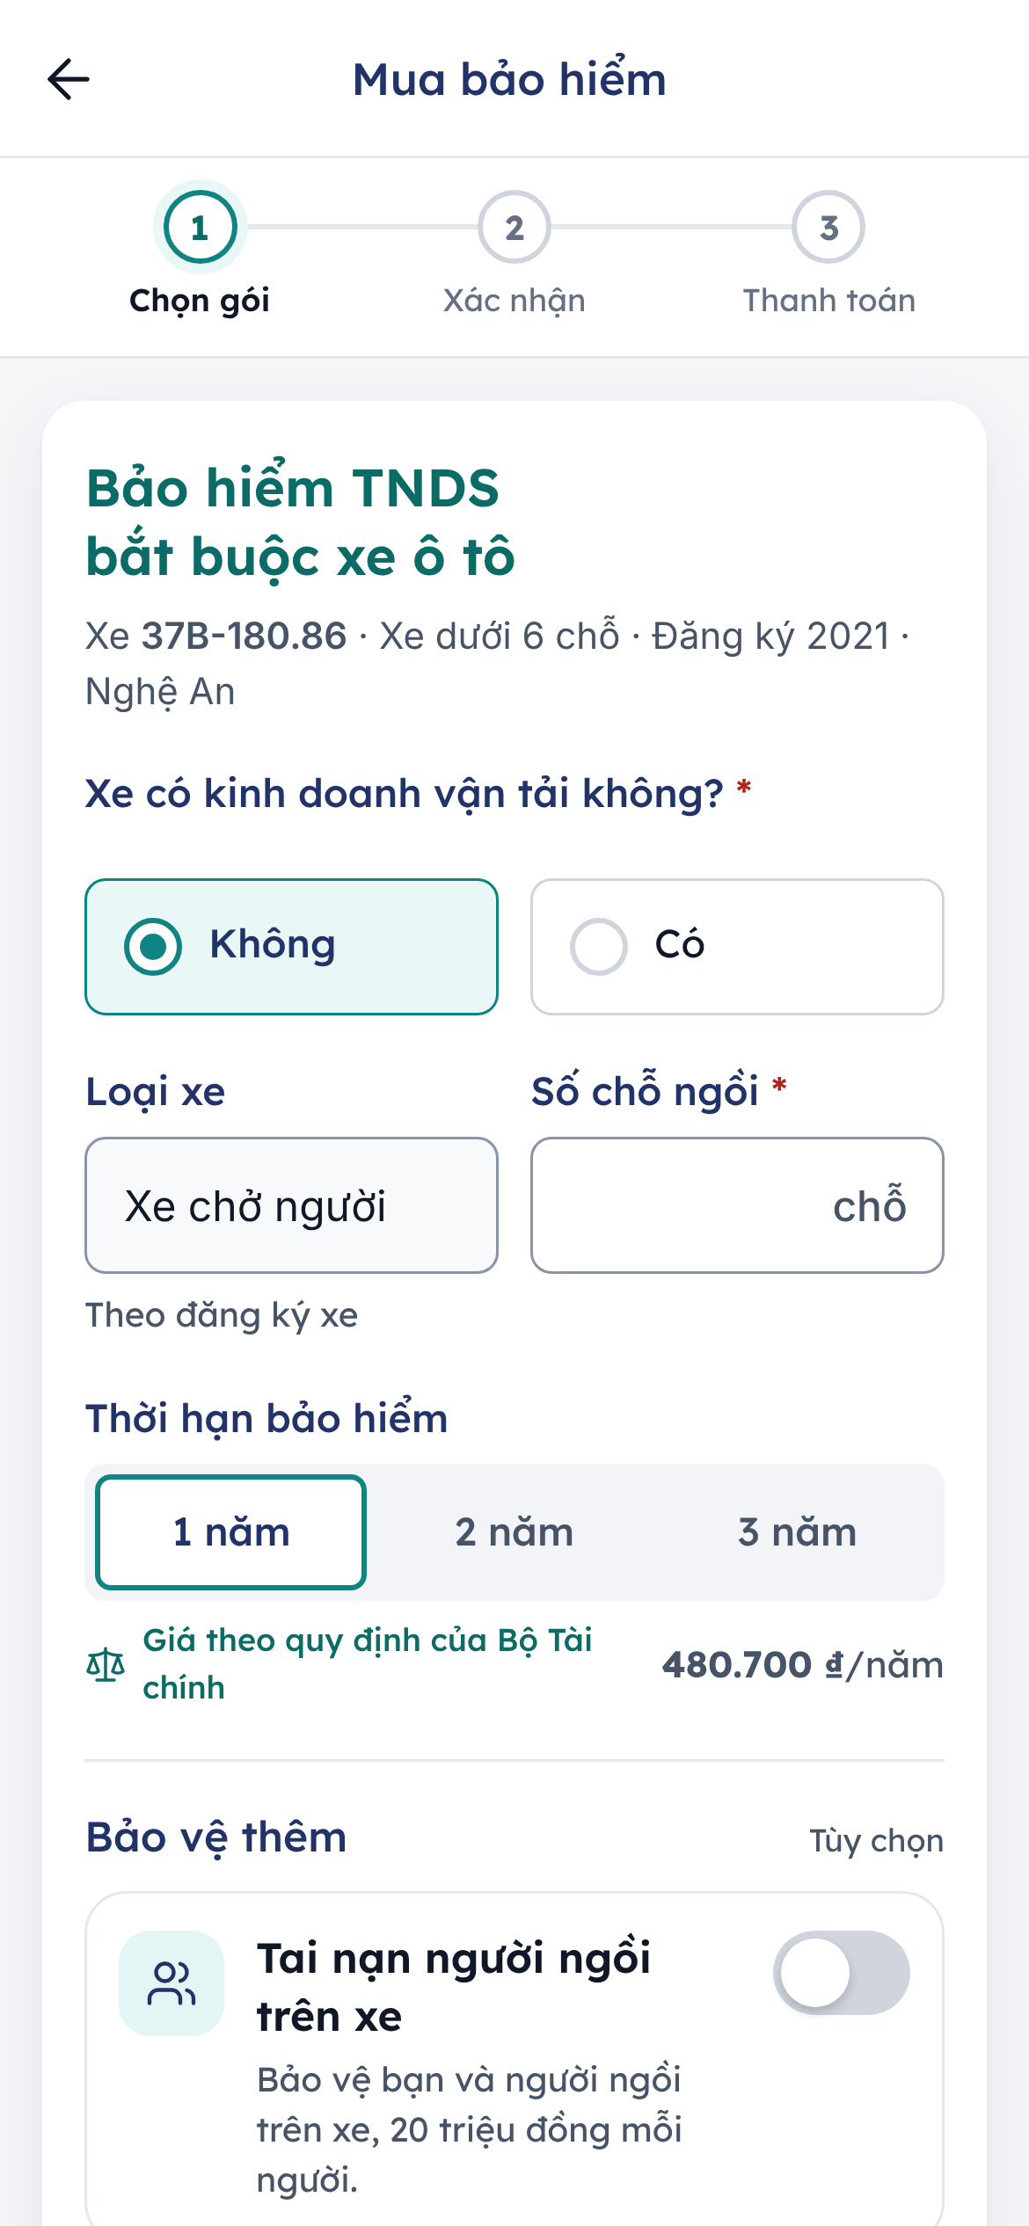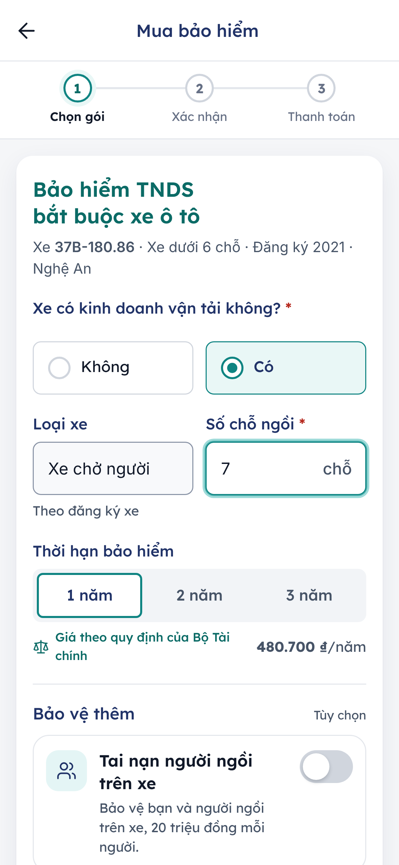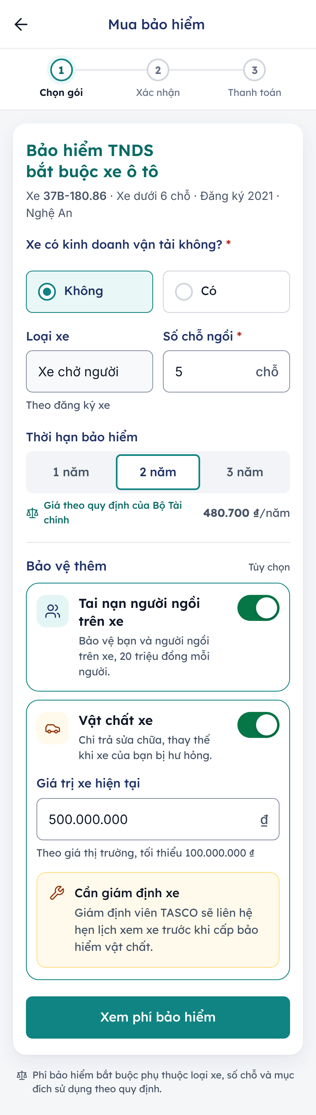
Figure 4 – Step 1: the quote form, the vehicle questions and the optional extra cover

Step 2: review
The review screen shows:
- the Thông tin xe (vehicle details) card, described below;
- Chi tiết phí (premium details): each product with its period, the premium and VAT, and the note Giá theo quy định của Bộ Tài chính on TNDS; then Phí bảo hiểm (chưa VAT), Thuế VAT and Tổng thanh toán. Accident cover for people carries no VAT, and the screen says so;
- Quyền lợi đi kèm, the benefits included;
- Báo giá có hiệu lực đến …, when the quote expires (24 hours after it was made).
Tap Tiếp tục (continue) to go to payment.

The vehicle confirmation card
The Thông tin xe card asks the customer to confirm the details the compulsory premium depends on: Xác nhận để tính đúng phí bảo hiểm bắt buộc. It shows the plate and vehicle, the question Xe có kinh doanh vận tải không? and Số chỗ ngồi, and the button Xác nhận thông tin xe.
Once confirmed, the card collapses to one line, for example “Không kinh doanh vận tải · 5 chỗ ngồi”, with a Sửa (edit) button. If the customer changes an answer, the app saves it, recalculates the quote and says “Đã cập nhật thông tin xe và tính lại phí.”
The customer cannot continue to payment until the vehicle details are confirmed; Tiếp tục then shows “Vui lòng xác nhận thông tin xe trước khi tiếp tục.” This matters most for quotes sent by telesales, which open directly at this step: the customer confirms the business use and seats before paying.
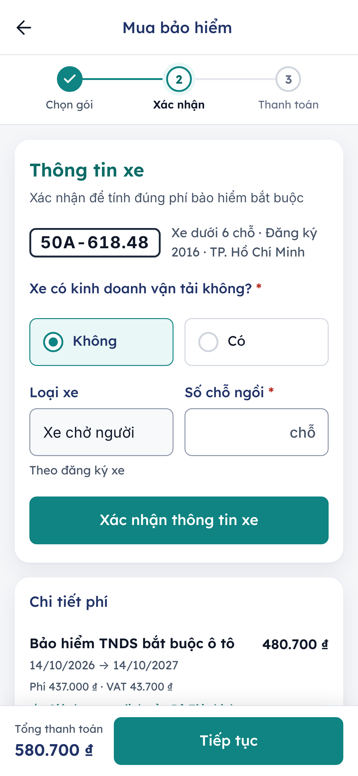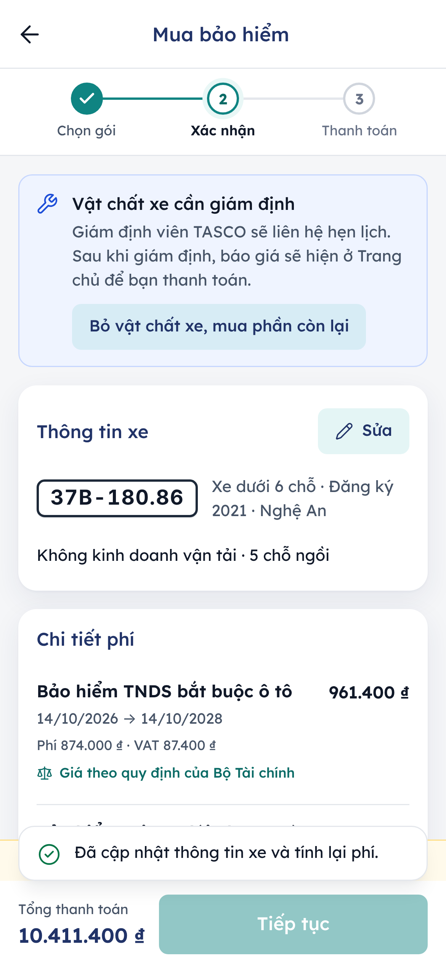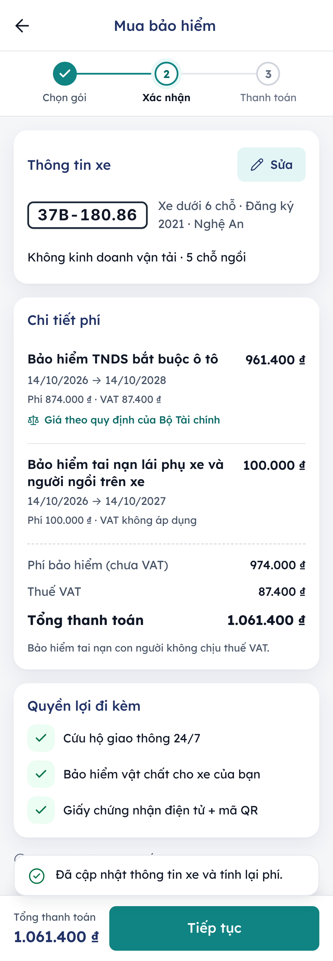
Figure 5 – Step 2: a telesales quote opening at the review step, the confirmed vehicle card and the premium details

When the customer cannot pay yet
Two notices can block payment. The bar at the bottom then explains why, and Tiếp tục does nothing.
- Đây là giá tạm tính (this is an indicative price): TASCO’s rating system was busy, so the price is provisional. Tap Xác nhận giá chính thức to get the confirmed price. If it differs, the app shows both: “Giá chính thức: … (giá tạm tính …)”.
- Vật chất xe cần giám định (physical damage cover needs an inspection): a TASCO assessor will call to arrange it. After the inspection the quote appears on the home screen for payment. To buy the rest now, tap Bỏ vật chất xe, mua phần còn lại (drop physical damage and buy the rest).

Step 3: pay
- Check Phương thức thanh toán (payment method). Inside the VETC app or the Zalo Mini App it is Ví VETC, with the wallet balance. In the TASCO app or on the TASCO website it is Thanh toán qua cổng TASCO (domestic ATM card, international card or bank QR). If the VETC wallet balance is too low, the notice Số dư ví chưa đủ says the host app will help the customer top up when confirming.
- Check Thông tin thanh toán: Đơn vị nhận (payee) Bảo hiểm TASCO, Nội dung (for example “Bảo hiểm xe 30E-949.35”), Số sản phẩm, Phí giao dịch (fee) Miễn phí (free) and Tổng thanh toán.
- Tick Tôi xác nhận thông tin xe chính xác và đồng ý với quy tắc bảo hiểm của TASCO. Without it, the app says “Vui lòng xác nhận trước khi thanh toán.”
- Tap Thanh toán followed by the amount.
- The sheet Xác nhận thanh toán shows the amount, method, payee and description. Tap Xác nhận thanh toán, or Để sau to stop.
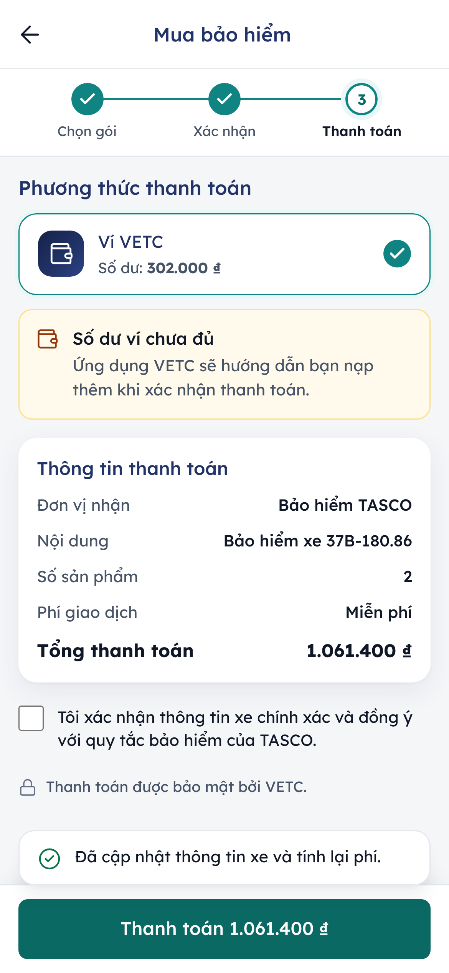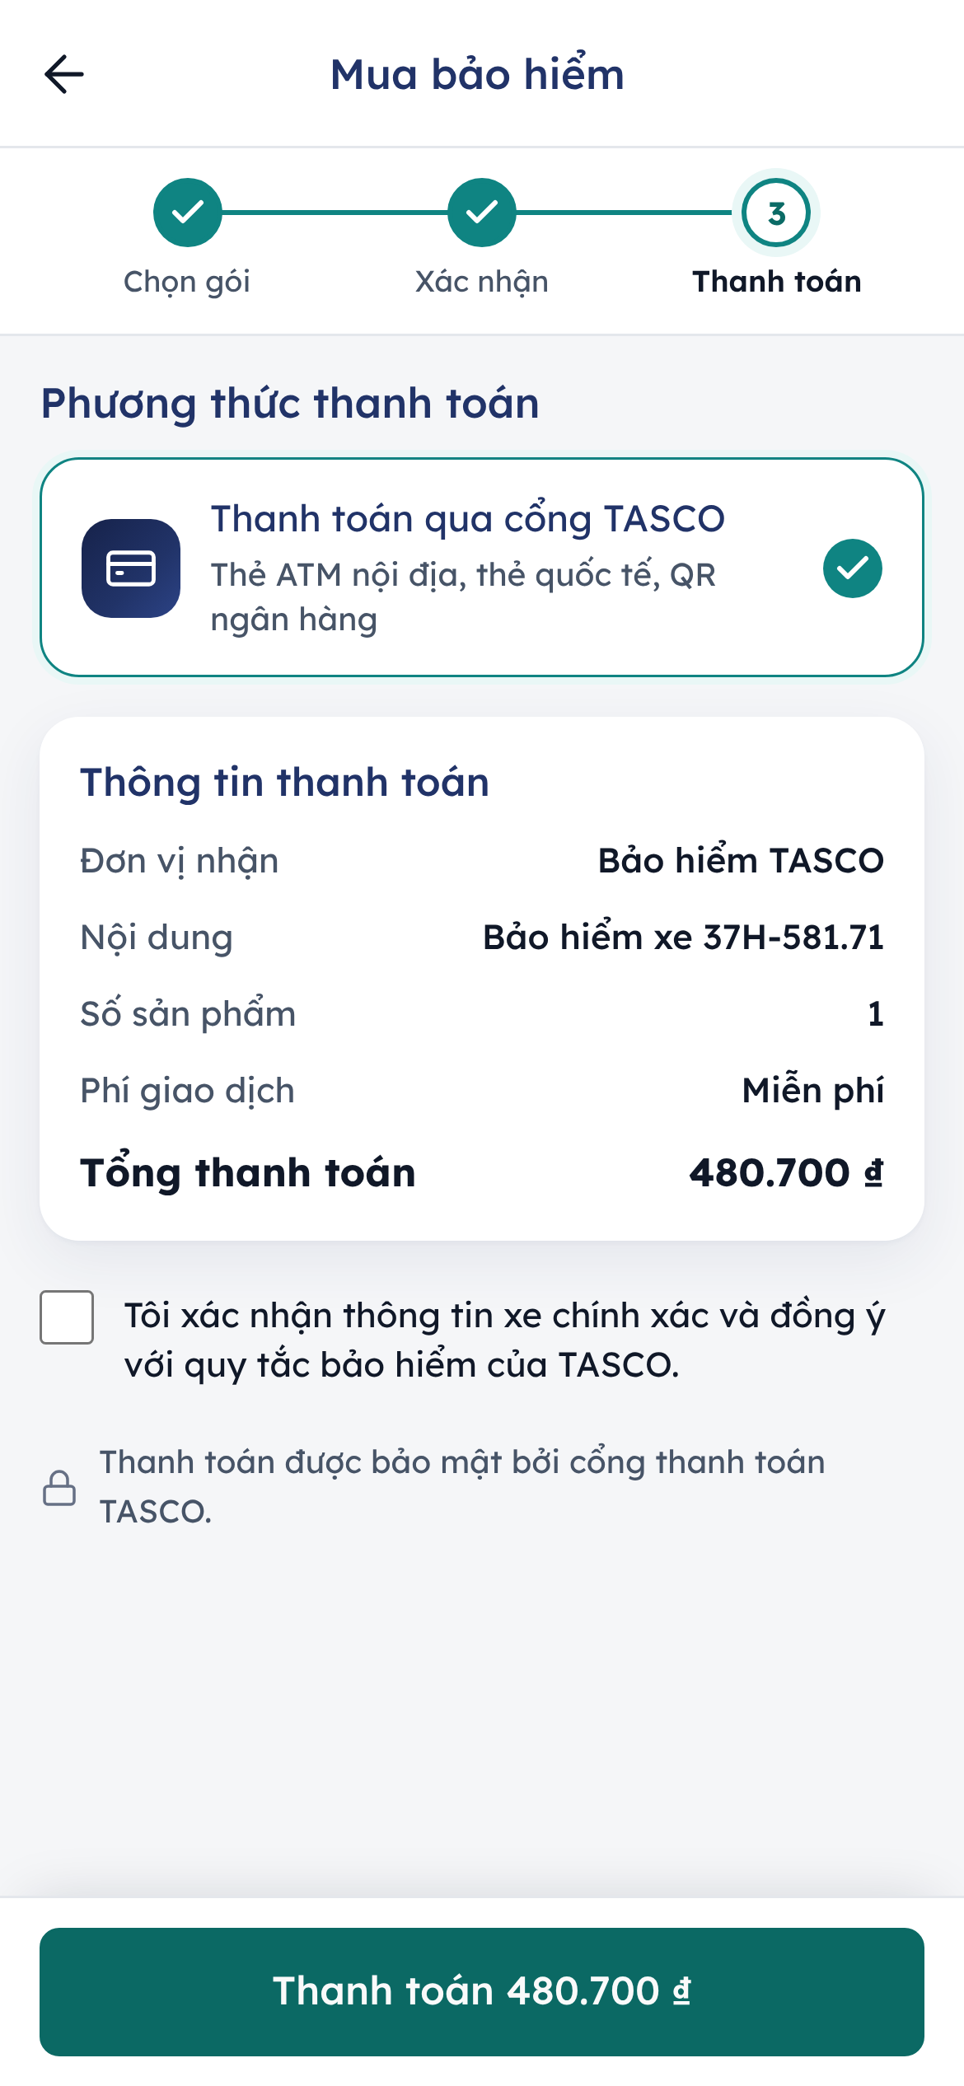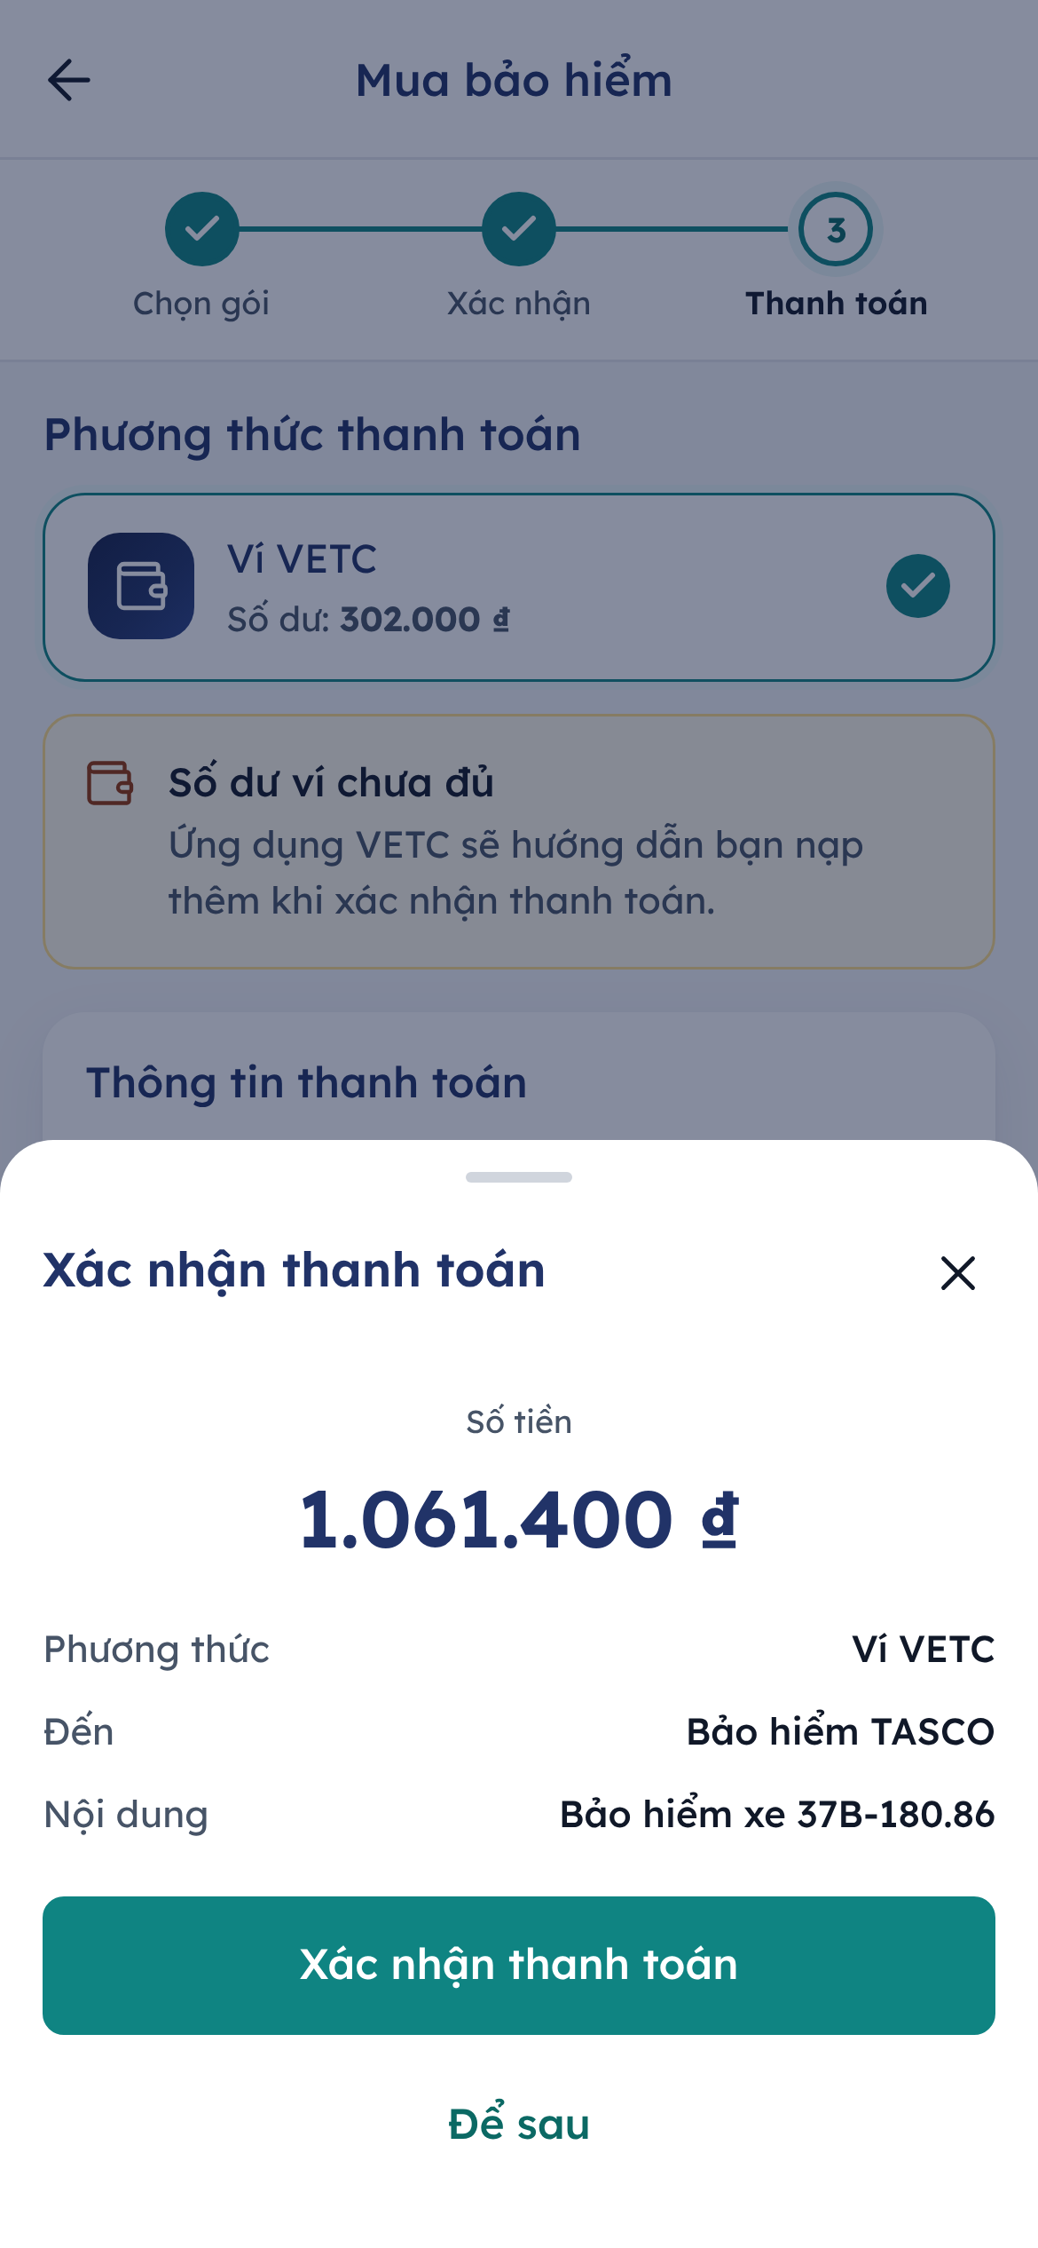
Figure 6 – Step 3: payment with the VETC wallet, payment on the TASCO website, and the confirmation sheet
While the payment is processed, the screen reads Đang xử lý thanh toán and asks the customer not to close the app. A payment is processed once only: tapping twice or a network retry never charges twice.
When it succeeds, Thanh toán thành công shows the amount, Mã giao dịch (transaction reference), the time, the policy numbers and the e-certificate card with its QR code. Lưu chứng nhận saves the certificate as an image; Về trang chủ returns home.
If it fails, Thanh toán chưa thành công explains the reason in plain Vietnamese and adds “Bạn chưa bị trừ tiền” (you have not been charged). Thử lại tries again. If issuance fails after the money was taken, the platform refunds it automatically.
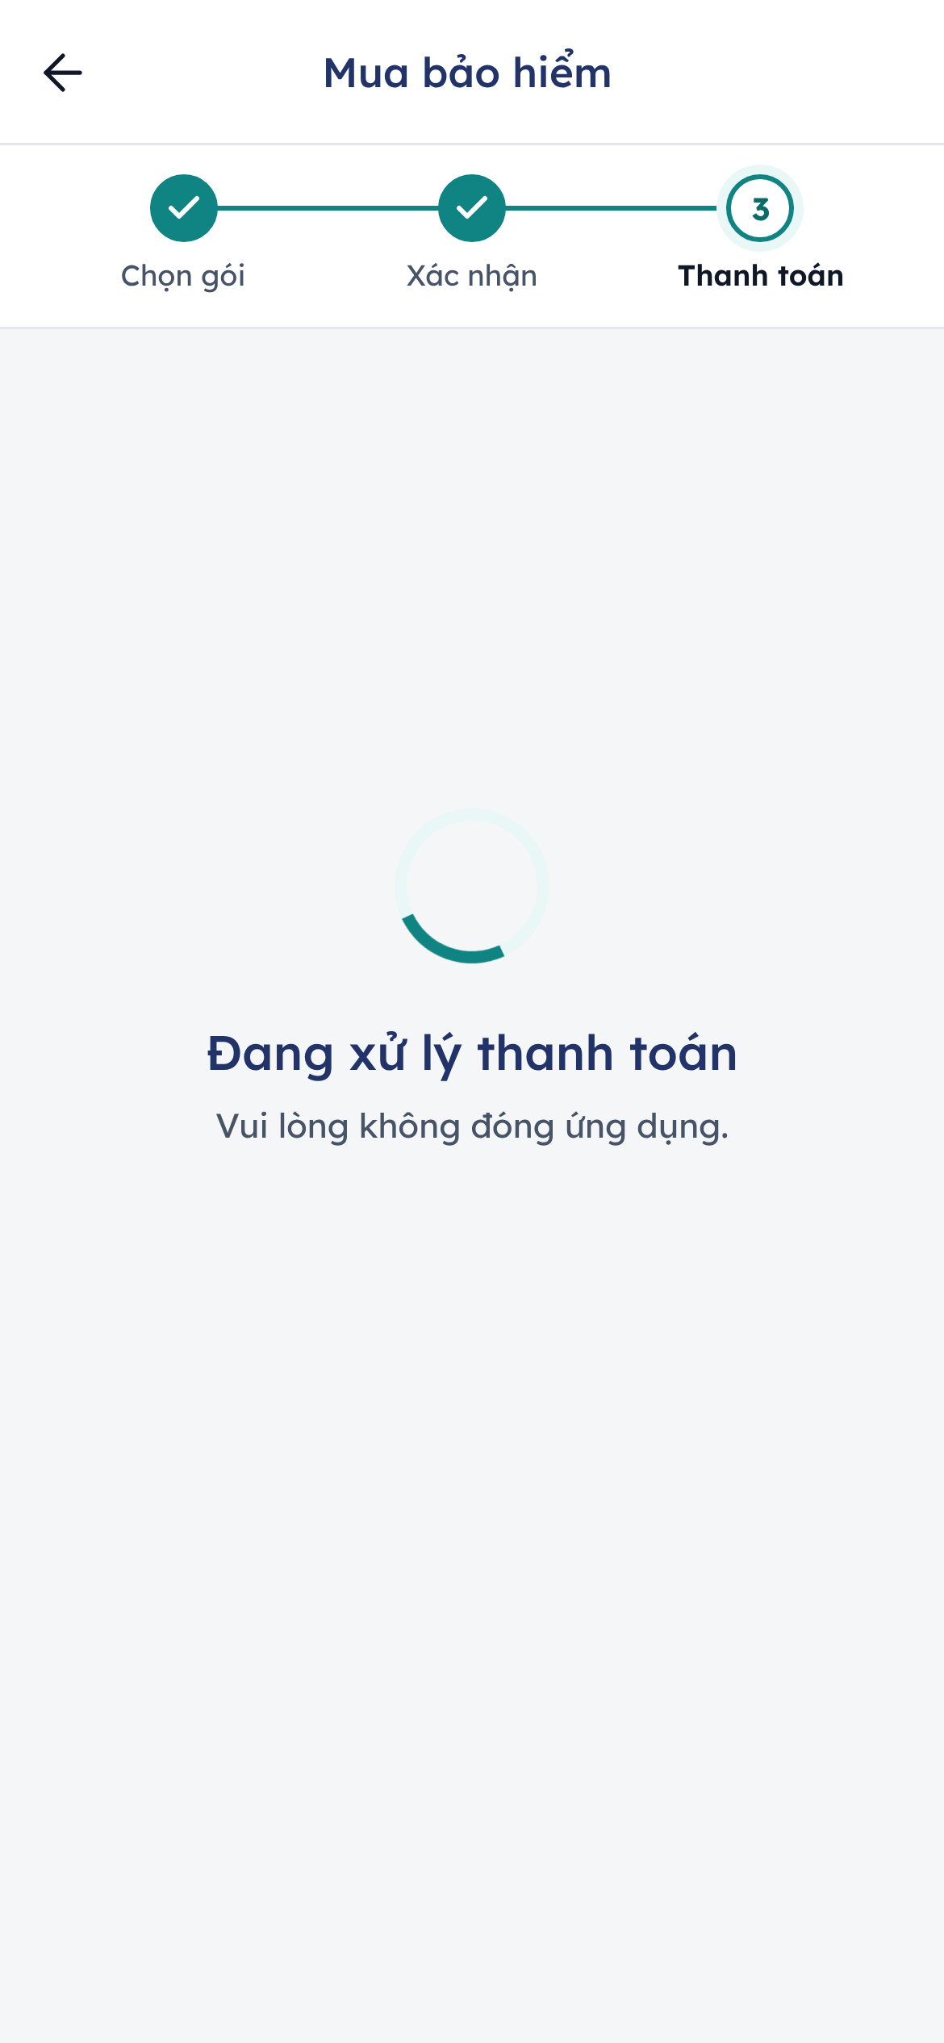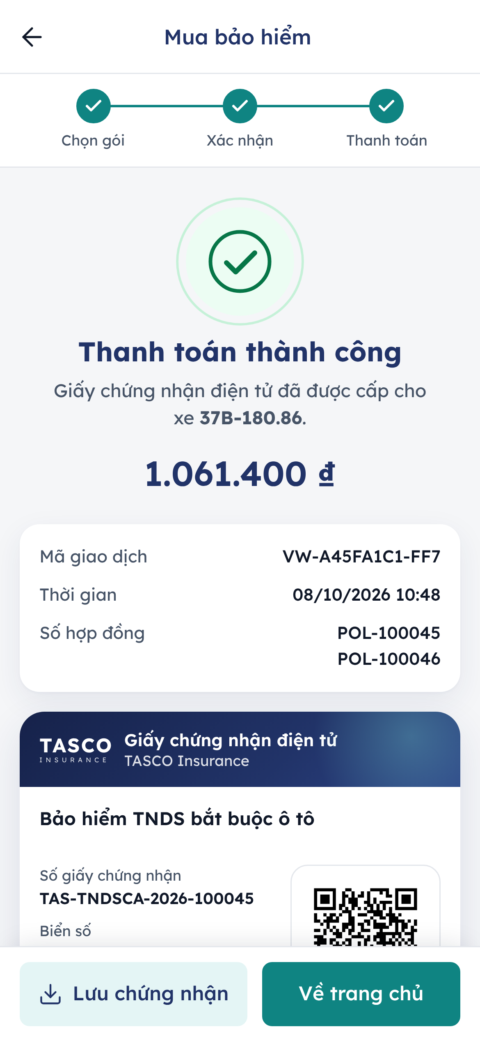
Figure 7 – Payment in progress and the success screen with the e-certificate

Example premiums
Cover | Premium | VAT | Total
TNDS, car under 6 seats, not commercial, 1 year | VND 437,000 | VND 43,700 | VND 480,700
Accident cover, 5 seats, VND 20 million each (illustrative rate) | VND 100,000 | None | VND 100,000
Both together | VND 537,000 | VND 43,700 | VND 580,700

My insurance and the e-certificate
Bảo hiểm của tôi lists the vehicle’s policies. Each card shows the product, Số GCN (certificate number), a status chip (Đang hiệu lực, Sắp hết hạn, Chưa đến ngày hiệu lực, Hết hạn or Đã hủy), Từ ngày and Đến ngày with a bar of the time used, the days left and Phí đã thanh toán (premium paid). Expired and cancelled policies are grouped under Đã hết hạn hoặc đã hủy.
Each card offers:
- the QR code with Phóng to (enlarge): the QR opens full screen with the certificate number, plate and period, and the hint Xuất trình mã này khi được cơ quan chức năng kiểm tra (show this code when checked by the authorities);
- Giấy chứng nhận điện tử: opens the online verification page;
- Lưu giấy chứng nhận: saves the certificate as a PNG image with the QR code, for use without a connection.
A customer without policies sees Chưa có hợp đồng với TASCO and a Mua bảo hiểm button.
Anyone, such as traffic police or an inspection centre, can scan the QR code. The verification page shows Giấy chứng nhận hợp lệ (valid certificate) with the product, a masked plate and the period, or a clear message when the certificate has expired, been cancelled or is not found. It shows no personal data.
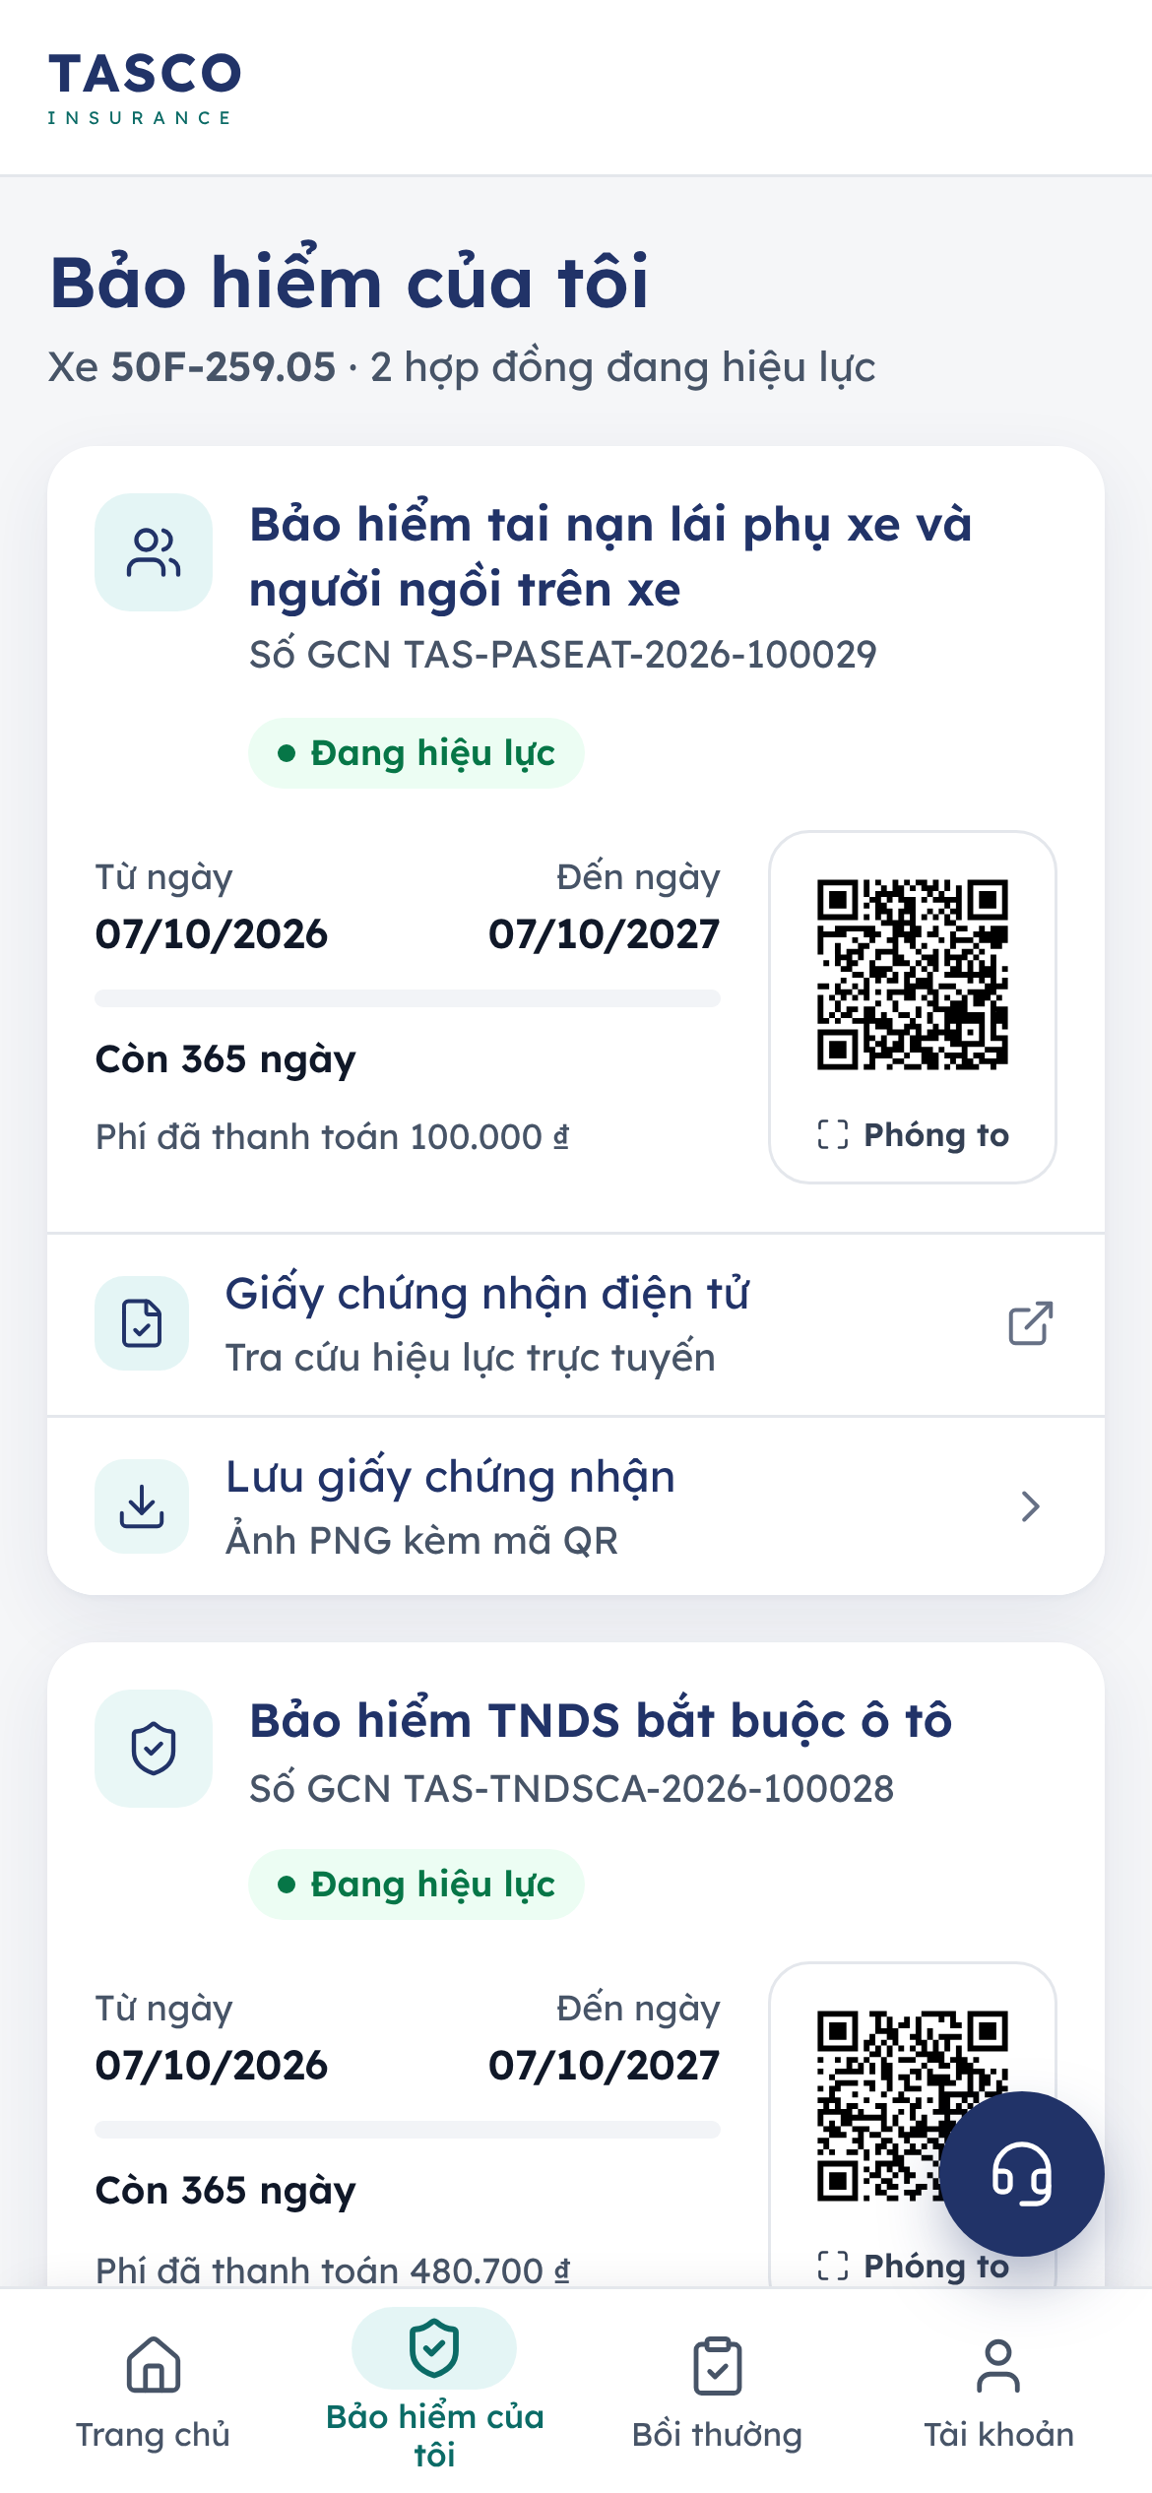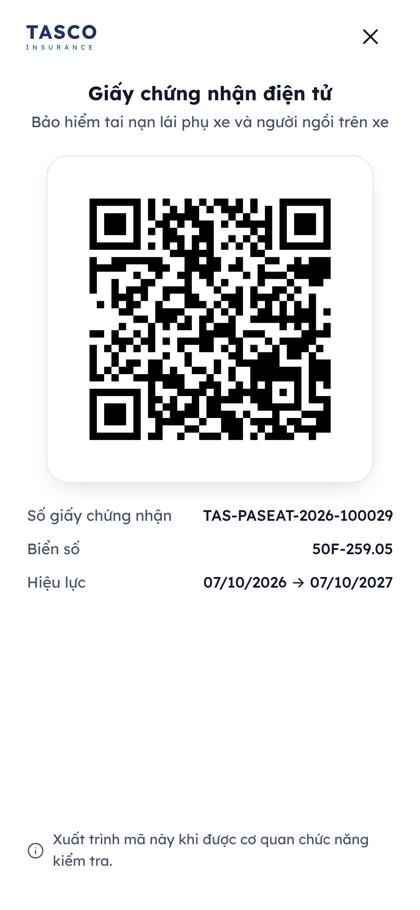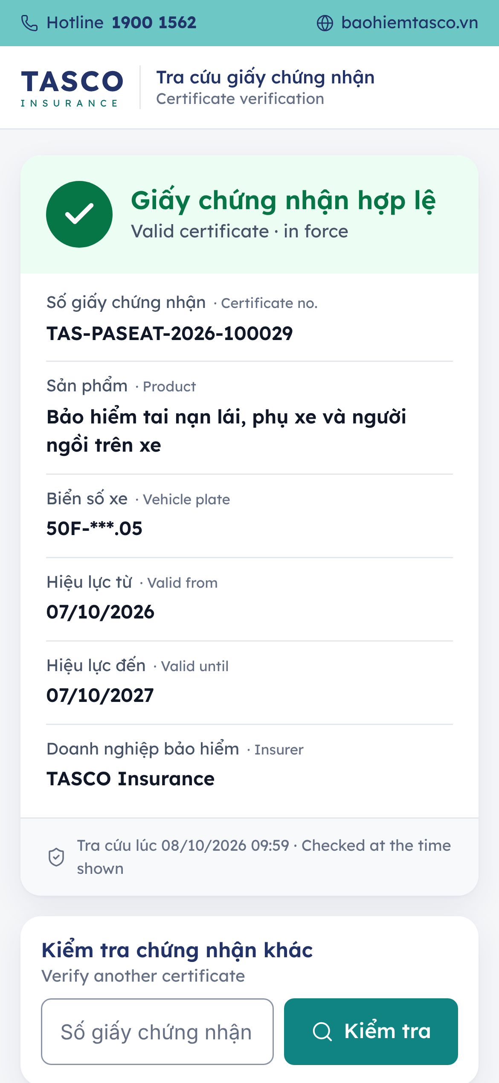
Figure 8 – My insurance, the full-screen QR code and the public verification page

Report an accident

In an emergency
Safety comes first.
- If anyone is injured, call 115 (ambulance) at once. The Bồi thường tab and the accident form both have a Gọi 115 button.
- Call 113 for the police if needed, and 114 for fire and rescue.
- For roadside help, call the TASCO hotline 1900 1562 (the Cứu hộ roadside assistance quick action on the home screen calls it).
- Report the accident in the app when it is safe to do so.

The claims tab
The Bồi thường tab shows:
- Báo tai nạn, to start a report (only when the vehicle has a TASCO policy in force; otherwise the notice Chưa có hợp đồng đang hiệu lực offers Mua bảo hiểm);
- the emergency buttons Cấp cứu 115 (for injuries) and the hotline 1900 1562 (Tổng đài TASCO), and the support e-mail for claim questions;
- Yêu cầu của tôi (my claims), each with its reference, status chip, product, incident date and place, a progress track and a line saying what happens next. Chi tiết yêu cầu shows the description, the number of photos and the history.
The progress track has five stages: Đã gửi (sent), Tiếp nhận (acknowledged), Giám định (assessment), Duyệt (approved) and Chi trả (paid). A rejected claim shows Từ chối at the decision stage and asks the customer to call the hotline for an explanation.

Submit a report
The form has five steps, shown as “Bước 1/5” with a progress bar.
- Chọn hợp đồng: choose the policy concerned.
- Thời gian và địa điểm: Ngày xảy ra (date, with shortcuts Hôm nay and Hôm qua; it must fall within the policy period and not in the future), Giờ xảy ra (time, optional) and Địa điểm (place, for example “Cao tốc Hà Nội – Hải Phòng, km 35”).
- Sự việc: choose the Loại sự việc (collision with another vehicle, collision with an obstacle, scratches and dents, flood or natural disaster, theft of parts, other), answer Có người bị thương không? and describe the event under Diễn biến sự việc (at least 10 characters). A red notice repeats: call 115 first if anyone is injured.
- Hình ảnh: take or choose up to nine photos: the whole scene, the plates of the vehicles involved and close-ups of the damage. Photos are optional (Bỏ qua và tiếp tục); the assessor collects the originals when they call.
- Xem lại và gửi: check each block, use Sửa to change one, tick Tôi cam đoan thông tin trên là đúng sự thật and tap Gửi yêu cầu bồi thường.
The confirmation Đã gửi yêu cầu bồi thường gives the claim reference and TASCO liên hệ trước (TASCO will contact you before), which is four hours after the report. The notice Giữ máy điện thoại asks the customer to keep the phone at hand for the assessor’s call.
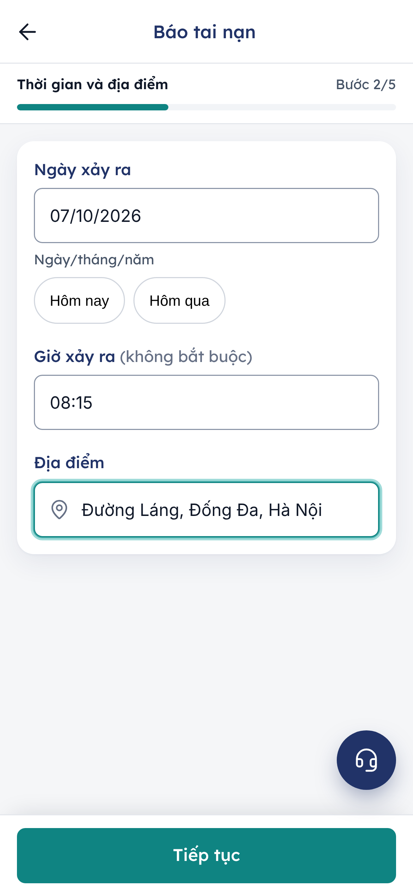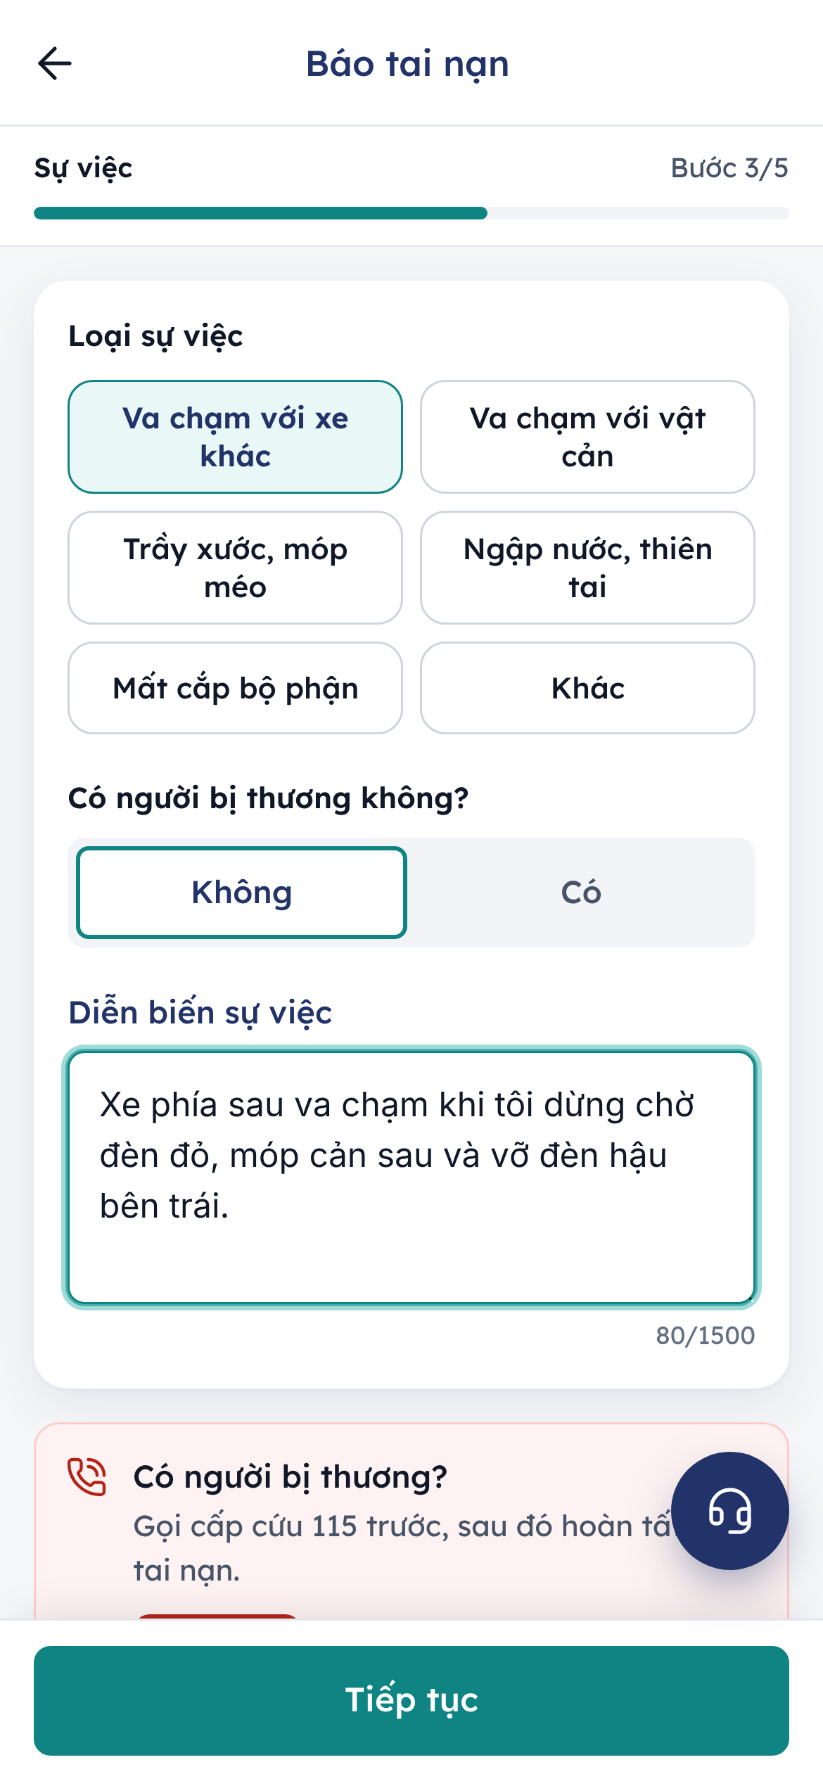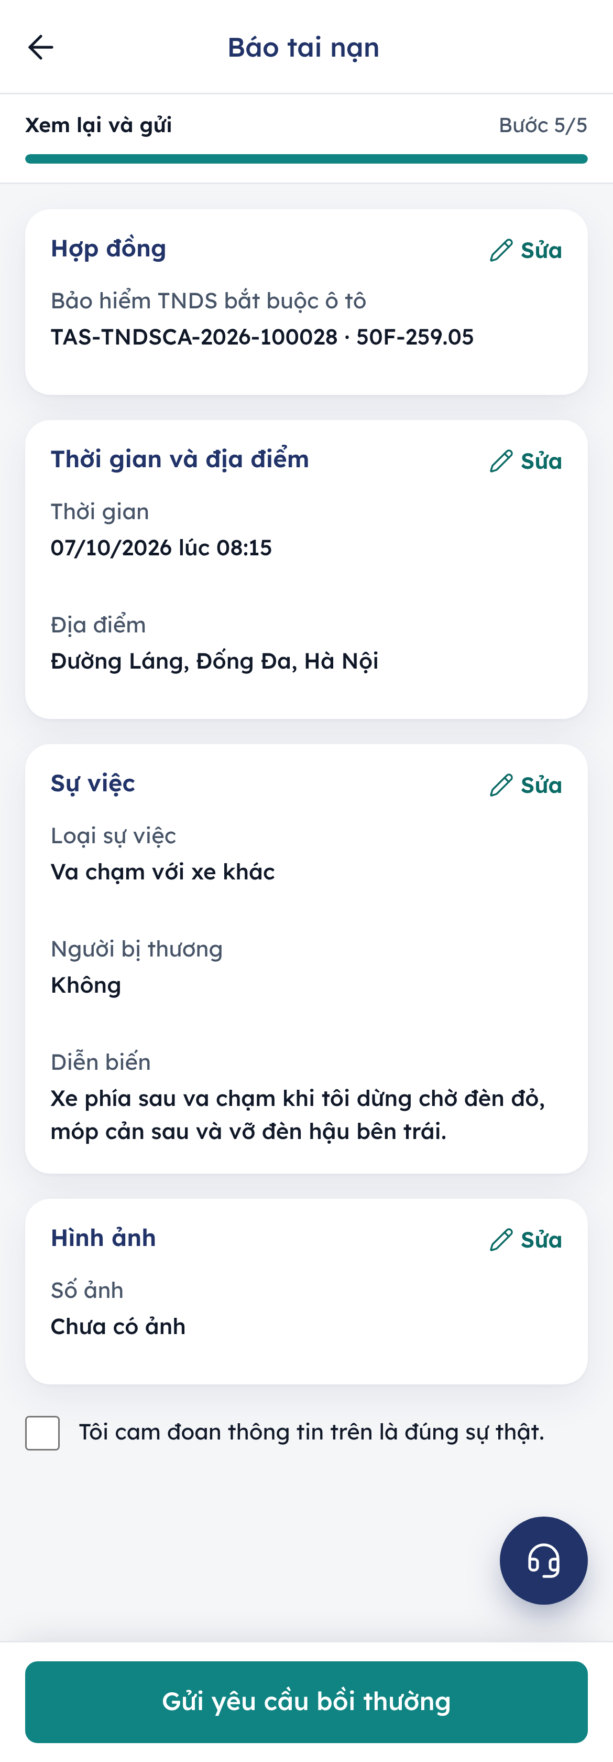
Figure 9 – Reporting an accident: when and where, what happened, and the review
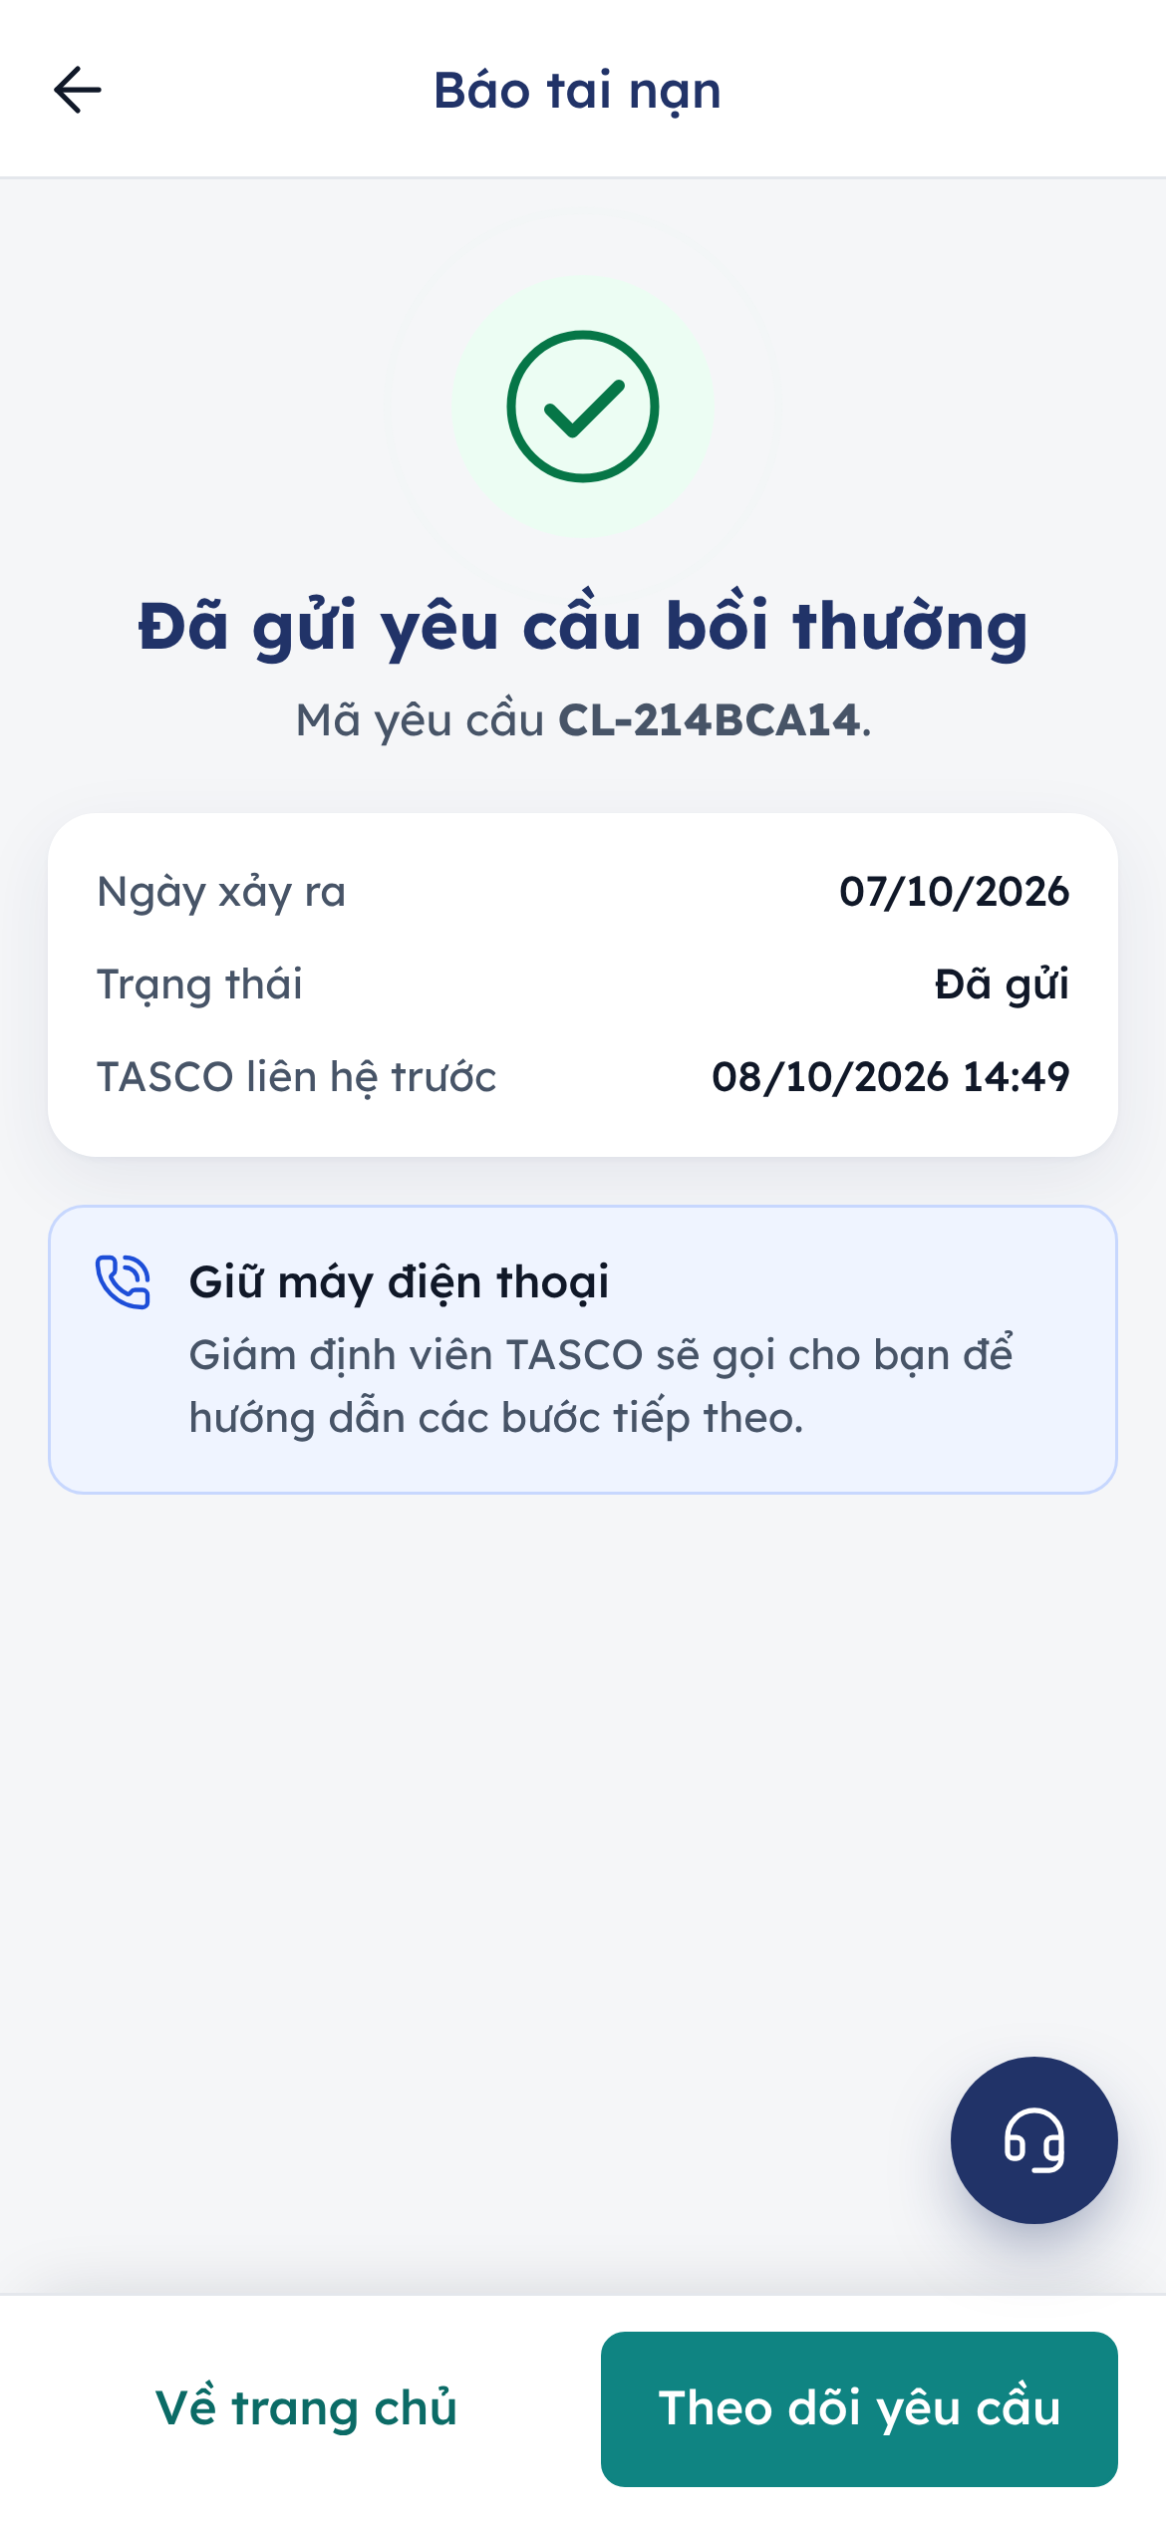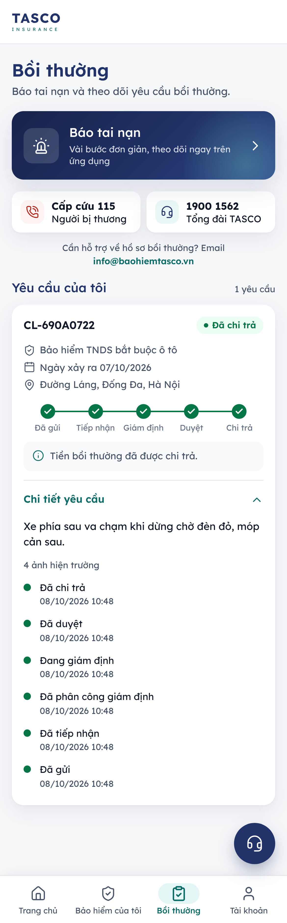
Figure 10 – The claim confirmation and the claim progress in the claims tab
Claims for policies bought from another insurer are handled by that insurer.

Account
The Tài khoản tab starts with the customer’s name and plate, then has three groups and Thoát (sign out).
Quyền riêng tư và liên lạc (privacy and contact) holds the consent switches. Each change is saved at once and confirmed with “Đã lưu lựa chọn của bạn”.
Switch | Meaning
Ưu đãi và thông tin sản phẩm | Offers and product information by app notification, Zalo and SMS
Cuộc gọi tư vấn | TASCO advisers and the voice assistant may call
Thông báo hiệu lực bảo hiểm | Notices about the validity of the cover; always on to protect the customer
A customer can also tell the voice assistant “đừng gọi nữa” (don’t call again); the request takes effect at once.
Dữ liệu cá nhân (personal data) has Tải dữ liệu của tôi, which downloads a copy of the data TASCO holds about the customer: vehicle, policies, quotes, orders, claims, messages and calls. Each download is recorded for TASCO compliance as a completed access request.
A customer who wants their data erased, or a copy sent by TASCO, asks through the hotline, e-mail, a branch or a letter. Staff pass the request to TASCO compliance, who log it in the staff console, verify the customer’s identity and answer within the response time (72 hours, to be confirmed by TASCO legal). Erasure is refused while a policy is in force, because the law requires the data to be kept until the policy ends. TGP-MAN-01 Staff Console User Manual describes the compliance steps.
Hỗ trợ (support) lists the same channels as the support sheet (see the next chapter) and Ngôn ngữ: the app follows the host’s language and is in Vietnamese.
Thoát signs the customer out of the insurance section. In demo environments only, Đổi khách hàng demo switches between demo customers; it never appears in production.
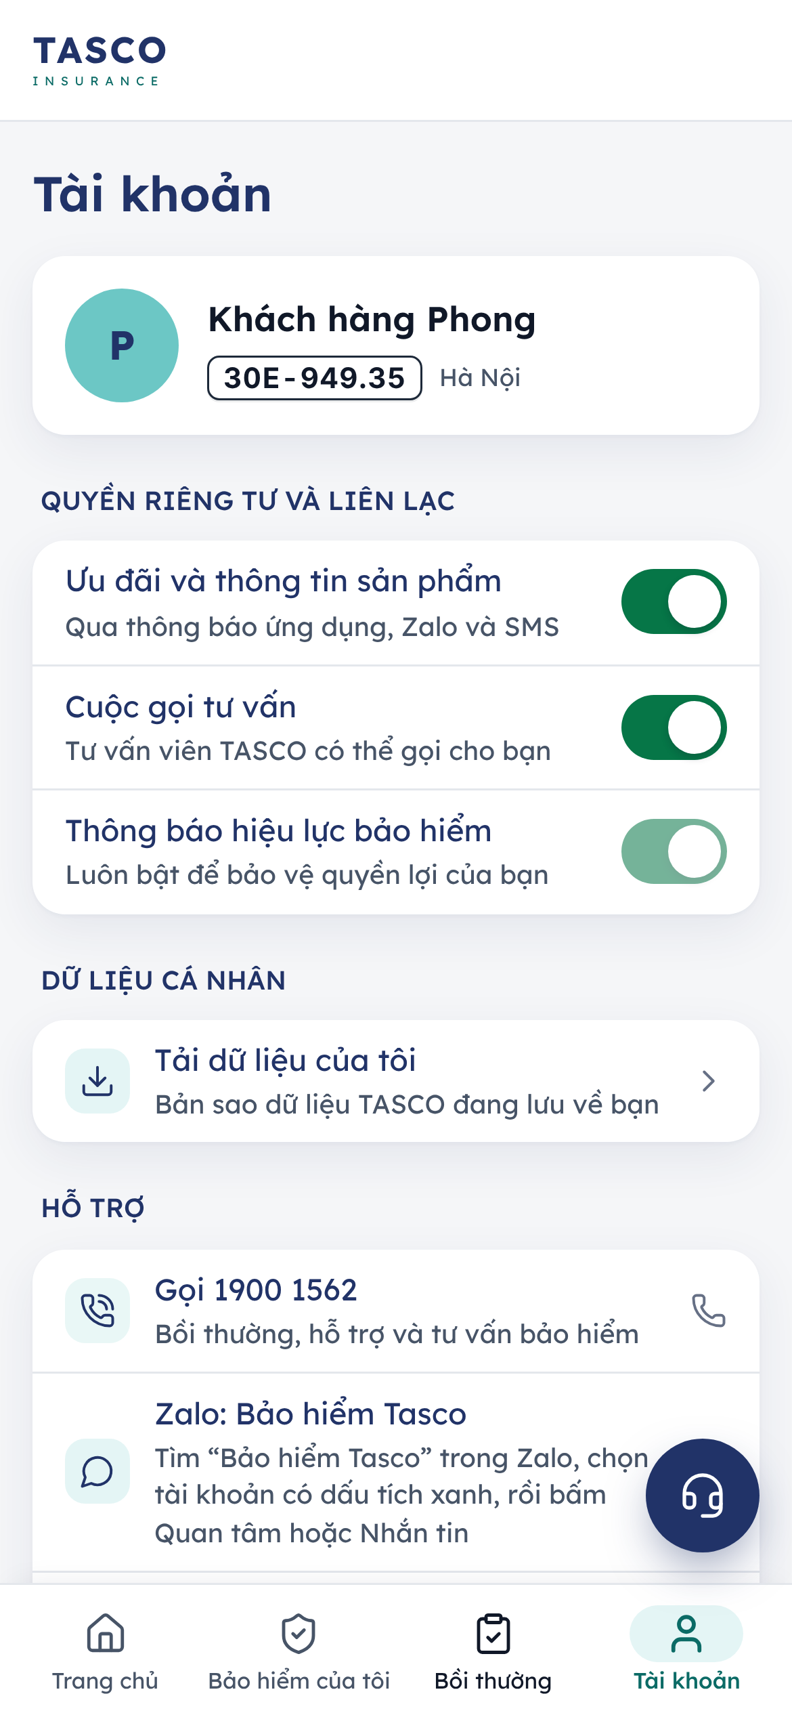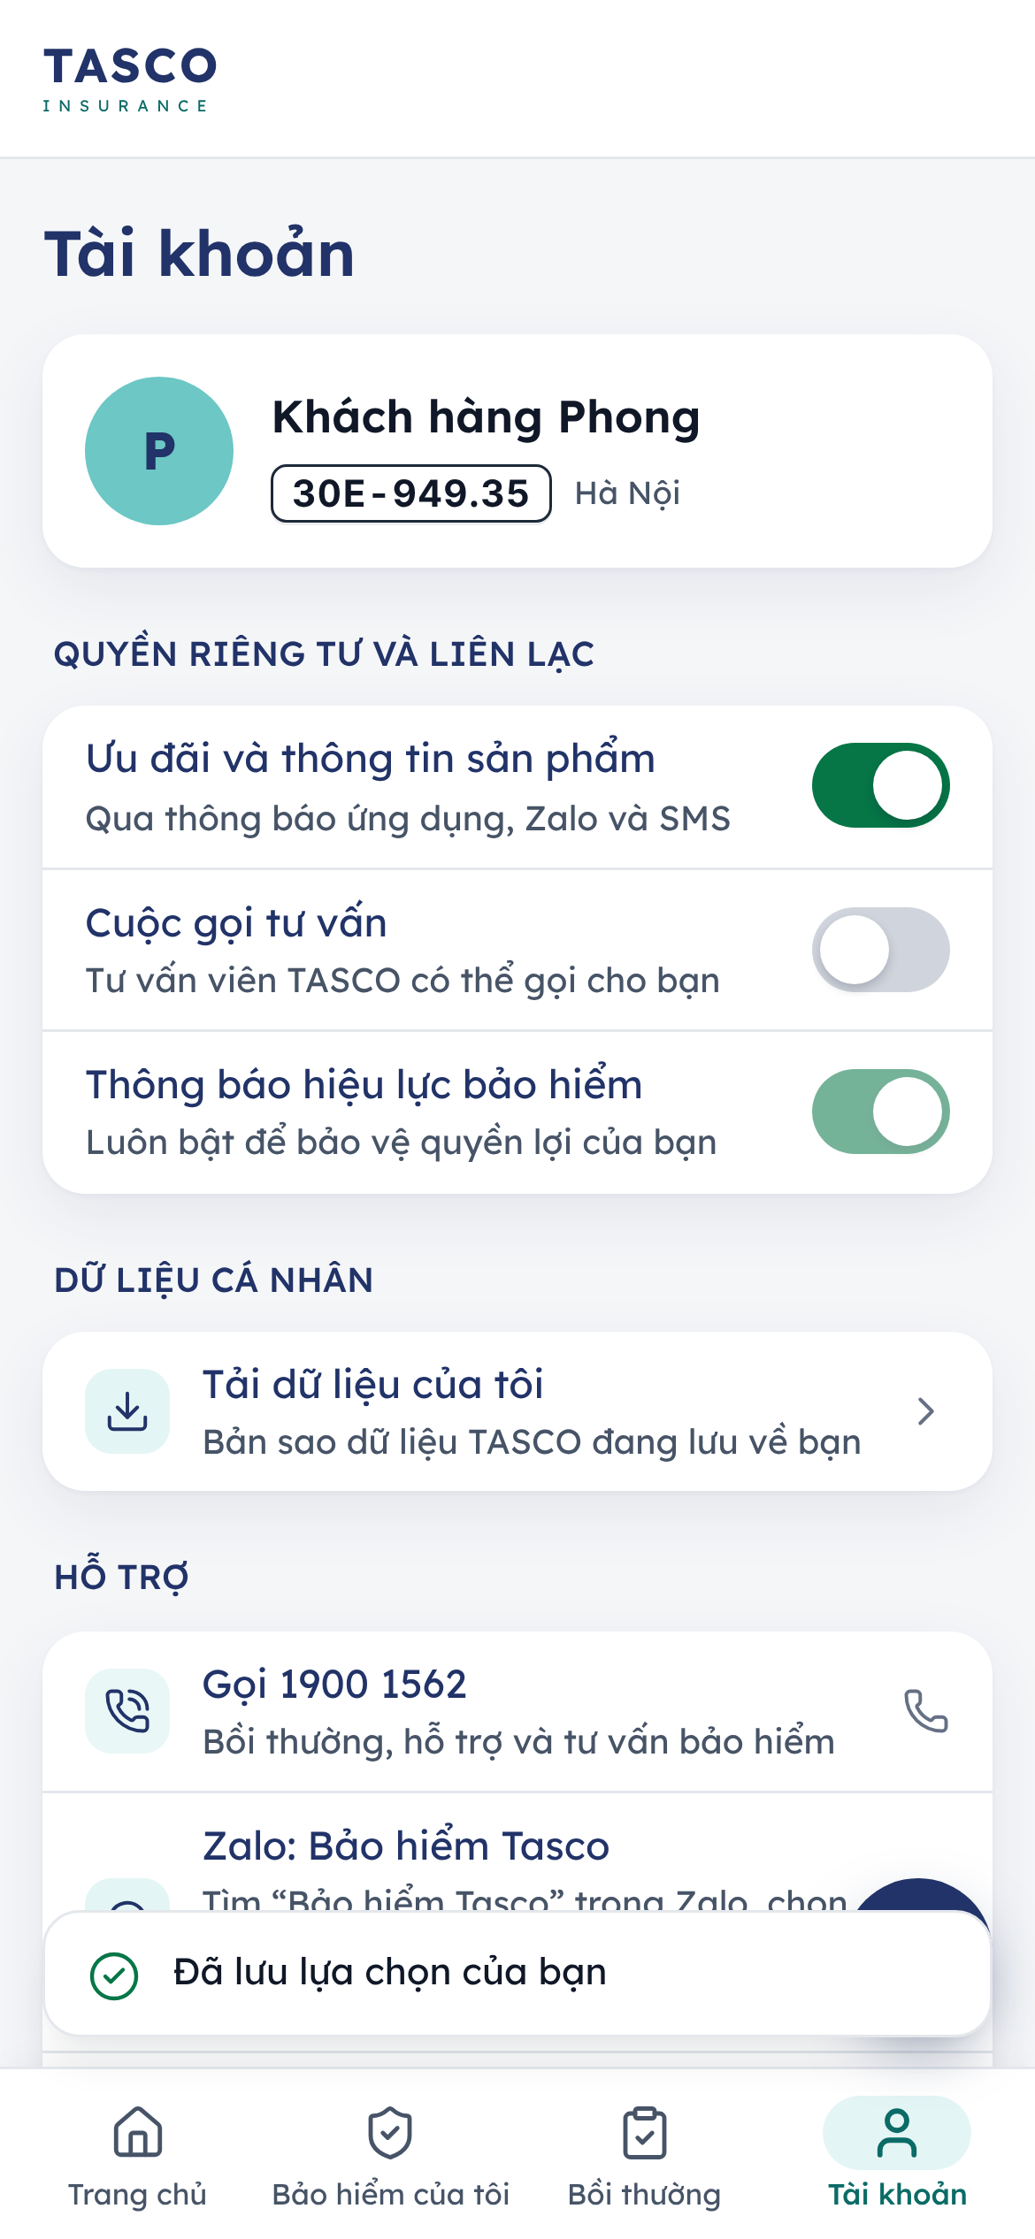
Figure 11 – The account tab and a saved consent choice

Contact TASCO
The support sheet (the headset button) and the Hỗ trợ group in the Account tab list TASCO’s official channels. A channel that is not configured is not shown.
Row in the app | Channel | Use
Gọi 1900 1562, Bồi thường, hỗ trợ và tư vấn bảo hiểm | Hotline 1900 1562 | The primary line for claims, general support and insurance questions
Zalo: Bảo hiểm Tasco | Zalo Official Account | Messages through Zalo
Nhắn tin qua Messenger | m.me/tasco.baohiem | Messages through Facebook Messenger
Fanpage Bảo hiểm TASCO | facebook.com/tasco.baohiem | TASCO’s Facebook page
Gửi email | info@baohiemtasco.vn | Written questions, documents
Trang web Bảo hiểm TASCO | baohiemtasco.vn | Product information and TASCO’s own channels
TASCO’s Zalo Official Account has no direct link. The row explains what to do: “Tìm “Bảo hiểm Tasco” trong Zalo, chọn tài khoản có dấu tích xanh, rồi bấm Quan tâm hoặc Nhắn tin”. In English: search for “Bảo hiểm Tasco” in Zalo, choose the account with the blue verified tick, then tap Quan tâm (follow) or Nhắn tin (message). Tapping the row copies the account name and confirms “Đã sao chép tên tài khoản Zalo”, so the customer can paste it into Zalo’s search.
The hotline is also called by the Cứu hộ quick action on the home screen, and appears in the claims tab and in the footer of the Account tab, with the e-mail address and the website.
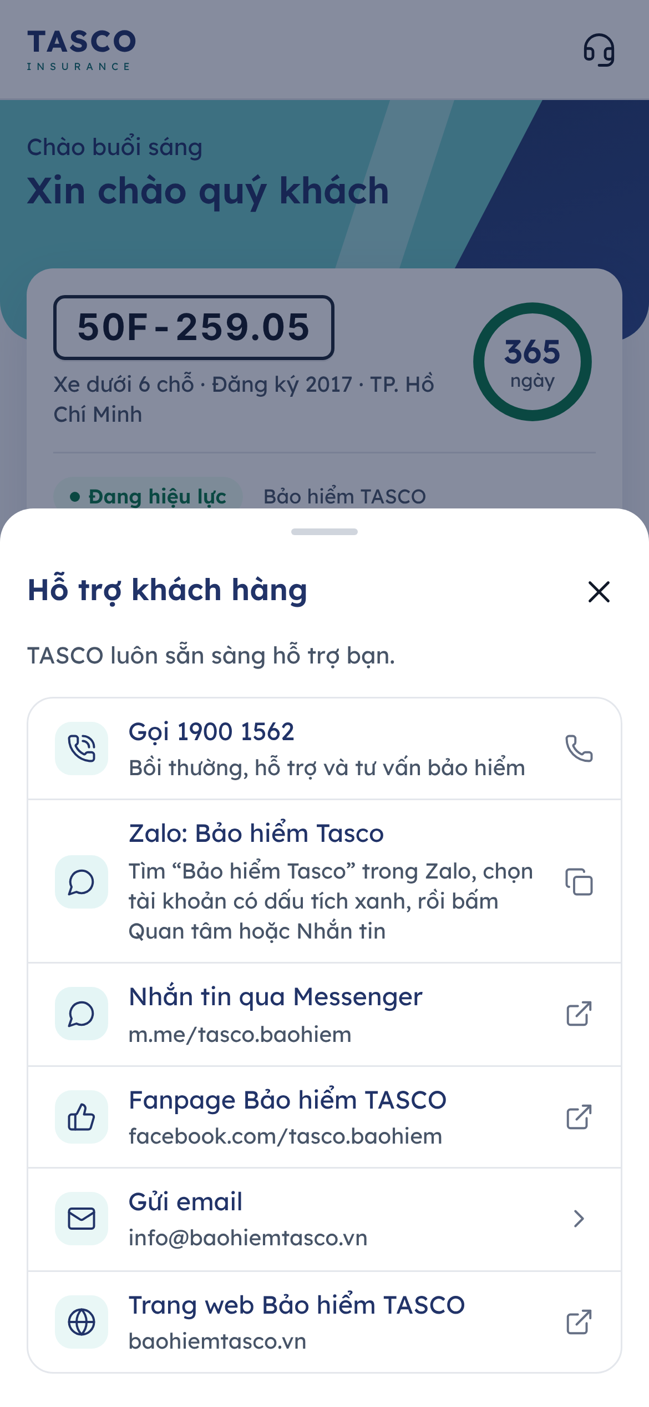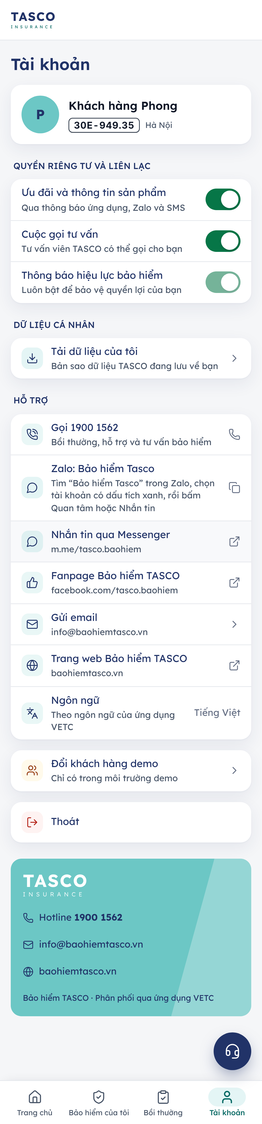
Figure 12 – The support sheet and the support group in the Account tab

Messages the customer may see
Message | Meaning | What to tell the customer
Phiên làm việc đã hết hạn. Vui lòng mở lại từ … | The session ended | Open the insurance section again from the host app
Liên kết đã hết hạn hoặc không hợp lệ … | The renewal link is older than 30 days or damaged | Open it from the host app or the latest message
Báo giá đã hết hạn. Vui lòng xem lại phí để nhận báo giá mới. | Quotes are valid for 24 hours | Start the purchase again to get a new quote
Báo giá này đã được thanh toán hoặc đang xử lý. | The quote is already paid or being paid | Check Bảo hiểm của tôi before trying again
Giá tạm tính cần được xác nhận trước khi thanh toán. | Indicative price | Tap Xác nhận giá chính thức
Bảo hiểm vật chất xe cần giám định xe trước khi thanh toán. | Inspection not yet done | Wait for the assessor, or buy without physical damage cover
Gia hạn nhanh chưa áp dụng cho xe này | The case no longer qualifies for quick renewal; the reason is shown underneath | Tap Gia hạn ngay and renew in the full flow
Cần xác nhận thông tin xe | Quick renewal needs the vehicle’s use and seats confirmed | Renew in the full flow and confirm the vehicle card; the next renewal can then be quick
Số dư ví VETC chưa đủ để thanh toán | The wallet balance is below the premium | Top up the VETC wallet, or renew in the full flow, where the host app helps to top up
Ngày xảy ra nằm ngoài thời hạn bảo hiểm của hợp đồng đã chọn. | The accident date is outside the policy period | Check the date or the policy chosen
Hệ thống TASCO đang bận. Vui lòng thử lại sau ít phút. | A TASCO system is temporarily unavailable | Try again in a few minutes; nothing was charged
Bạn thao tác quá nhanh. Vui lòng thử lại sau ít phút. | Too many requests in a short time | Wait a moment
Không có kết nối mạng. Vui lòng kiểm tra và thử lại. | No network connection | Check the connection

Frequently asked questions

Is the call from the automated assistant genuine?
Yes. The assistant always says it is automated, asks the customer to read the plate (it never reads the plate first) and never asks for an OTP or payment by phone. The customer can ask for a link and check everything in the app.

Why do I see “Gia hạn nhanh” and my friend does not?
Quick renewal is offered when TASCO already holds everything needed to renew the same cover: a TNDS renewal, confirmed vehicle details, no physical damage cover and, in the VETC app, enough wallet balance. Otherwise the app shows Gia hạn ngay and the full flow, which takes a few more taps. Both give the same cover at the same regulated price.

Is it cheaper to buy in the app?
No. The TNDS premium is set by regulation and is the same everywhere. Buying in the app is faster, the e-certificate arrives at once, and the cover comes with roadside assistance and reminders.

A telesales advisor sent me a quote. How do I pay?
Open the app. The quote is on the home screen under Báo giá đang chờ bạn xác nhận. Tap Xem và thanh toán, confirm the vehicle details and pay in the app. Advisers never take money or OTP codes by phone.

I already bought insurance elsewhere. How do I stop the reminders?
Tap Cập nhật ngày hết hạn or Xác nhận ngay on the home screen and enter the new expiry date and insurer. Marketing messages can also be switched off in Tài khoản.

The payment failed. Was I charged?
When the app says Thanh toán chưa thành công, the customer has not been charged. If money left the wallet or card but no certificate was issued, the platform refunds it automatically; the customer can call 1900 1562 with the time of the transaction.

I sold the car or the assistant called the wrong person.
Tell the assistant “nhầm số” (wrong number), or call the hotline. TASCO updates the record.

Appendix

Screen and label summary
Screen | Main labels
Tab bar | Trang chủ · Bảo hiểm của tôi · Bồi thường · Tài khoản
Home | Gia hạn nhanh · Tùy chỉnh gói bảo hiểm · Gia hạn ngay · Mua bảo hiểm ngay · Cập nhật ngày hết hạn · Xem và thanh toán · Cứu hộ · Báo tai nạn
Quick renewal | Gia hạn nhanh · Gia hạn TNDS bắt buộc · Phương thức thanh toán · Xác nhận thanh toán · Tùy chỉnh gói bảo hiểm
Purchase stepper | Chọn gói · Xác nhận · Thanh toán
Quote form | Xe có kinh doanh vận tải không? · Loại xe · Số chỗ ngồi · Thời hạn bảo hiểm · Bảo vệ thêm · Xem phí bảo hiểm
Review | Thông tin xe · Xác nhận thông tin xe · Chi tiết phí · Tổng thanh toán · Tiếp tục
Payment | Phương thức thanh toán · Ví VETC / Thanh toán qua cổng TASCO · Xác nhận thanh toán
Claim form | Chọn hợp đồng · Thời gian và địa điểm · Sự việc · Hình ảnh · Xem lại và gửi
Support | Hỗ trợ khách hàng · Gọi 1900 1562 · Zalo: Bảo hiểm Tasco · Nhắn tin qua Messenger · Fanpage Bảo hiểm TASCO · Gửi email · Trang web Bảo hiểm TASCO

Sign-Off
Serial Number | Description | Owner | Status
1 | Hosting of the customer app inside the TASCO app and on the TASCO website, and the TASCO payment gateway, confirmed with TASCO IT | TASCO IT | Open
2 | Support channels shown in the app (hotline 1900 1562, info@baohiemtasco.vn, baohiemtasco.vn, Fanpage, Messenger and the Zalo Official Account) confirmed as current | TASCO Customer Service | Open
3 | Wording of the payment declaration and the claim declaration to be confirmed by TASCO legal | TASCO Compliance | Open
4 | Conditions for quick renewal ("Gia hạn nhanh") confirmed: renewal journey or TASCO TNDS renewal, vehicle use and seats confirmed within 365 days, TNDS only, wallet balance on VETC hosts | TASCO Product Owner and TASCO Compliance | Open
5 | Seat accident and physical damage rates replaced by TASCO filed rates before go-live | TASCO Product Owner | Open

Sign Off Date | Signature | Approved By | Department & Project Role
 |  | TASCO Insurance | Programme Sponsor
 |  | TASCO Insurance | Product Owner
 |  | iorta TechNXT | Business Analysis and User Experience



